• •

)

� [nadav@nszlegal.com](mailto:nadav@nszlegal.com)

FILED

**Court of California**

Ca!, 3

@s 4

a

5

6

7

8

**By**, **Deputy**

SUPERIOR COURT OF THE STATE OF CALIFORNIA

9

COUNTY OF LOS ANGELES

10

11

) 7 2 O

12 - -, an individual; Case No. BC 6 5 9

)

- -, an individual, ) 13 )

Plaintiffs, )

14

**VERIFIED COMPLAINT FOR:**

v.

15

- -, aka - T. -, aka

1. - - -, individually, as

)

) **(2)**

)

)

personal representative of - (-) E. )

1. -, deceased, and as trustee of the ) )

)

-. )

1. a California Corporation; ESTATE OF ) - (-) E. -, ) deceased; - -, individually and ) as personal representative of - (-) )

�o

1. E. -, deceased; - , aka )

- -, aka-, an )

1. individual; and DOES )

)

23

:ti -0 ,;:, A)

)

Defendants.

*!:2 � m hi*

(,:2:

**l,J'**

)

24 )

1. m **� �**....

:ti.i::�:t:*m* 'O•• , . o :#:

r-, ....; ,.,)

··-, 25

(:�:

1. **..**

*t*.l:,.*� fl:*,::-, £,.,

**I-•**·**�**•-.**·** 26

&

c:• , ,_0 rlJ ·

r,-•.

O··--..

F.j

i::::: 27

,--·

�--.

28

.r:.,

**JURY TRIAL DEMANDED** 0

,:::,

,:::, '-0

I\.) (..•�

VERIFIED cogi,�ftoR P.AllAGEs, DECLARATORY� ffiJaNCTB'E RELIEF

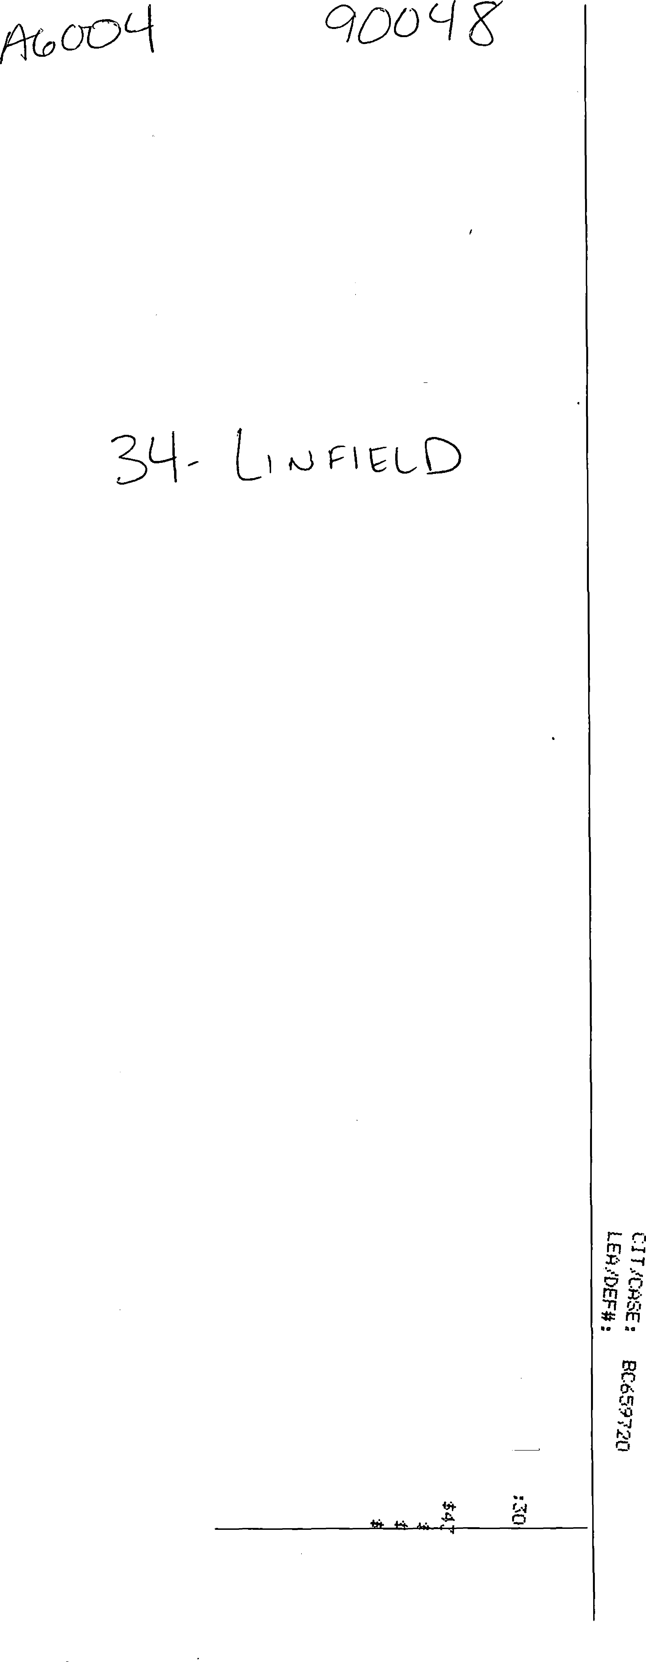



1

2

3

4

5

6

7

8

9

10

11

12

13

14

15

16

17

18

19

20

21

22

23

c;::: 24

*r*

.,, 25

..:.:.:

.,, 26

r,,.

.r..:.::.:

27

....,

28

**COMES NOW,** Plaintiffs **- -,** an individual ("-"); and **- -,** an individual ("-"); who hereby complain against Defendants **- -,** aka - T. -, aka - - -, individually, as personal representative of - (-) E. -, deceased, and as trustee of the -

{-) E.

**,** a California Corporation; **ESTATE OF - (-) E. -,** deceased ("- Estate"); **- -,** individually and as personal representative of - (-) E. -, deceased; **- YE,** aka - -, aka MISTRESS -, an individual ("Mistress -" or " Defendant"); and **DOES 1 through 10, inclusive,** and allege, upon personal knowledge as to themselves and their own acts, and upon information and belief as to all other matters, as follows:

**GENERAL ALLEGATIONS**

1. The subject property is located in the State of California,
2. - - and - - are natural persons who, at all times relevant to this action, were and are tenants residing at the downstairs unit of the
3. On November 1, 2012, Plaintiffs entered into a two-year lease agreement (the "Lease") to rent the Apartment from - (-) E. - ("Mr. -"), now deceased. Under the terms of the Lease, the Plaintiffs were obligated to pay) per month, tendering that sum. A true and correct copy of the lease is attached hereto as Exhibit "A."
4. On or about 2014, Defendant - Ye entered into a written lease with Mr. - to rent the upstairs unit (the "Top Apartment") and moved into the Top Apartment immediately thereafter.

-1- VERIFIED COMPLAINT FOR DAMAGES, DECLARATORY AND INJUNCTIVE RELIEF

1

2

3

4

5

6

7

8

9

10

11

12

13

14

15

16

17

18

19

20

21

22

23

24

c.:::

*.I'*

25

(2:

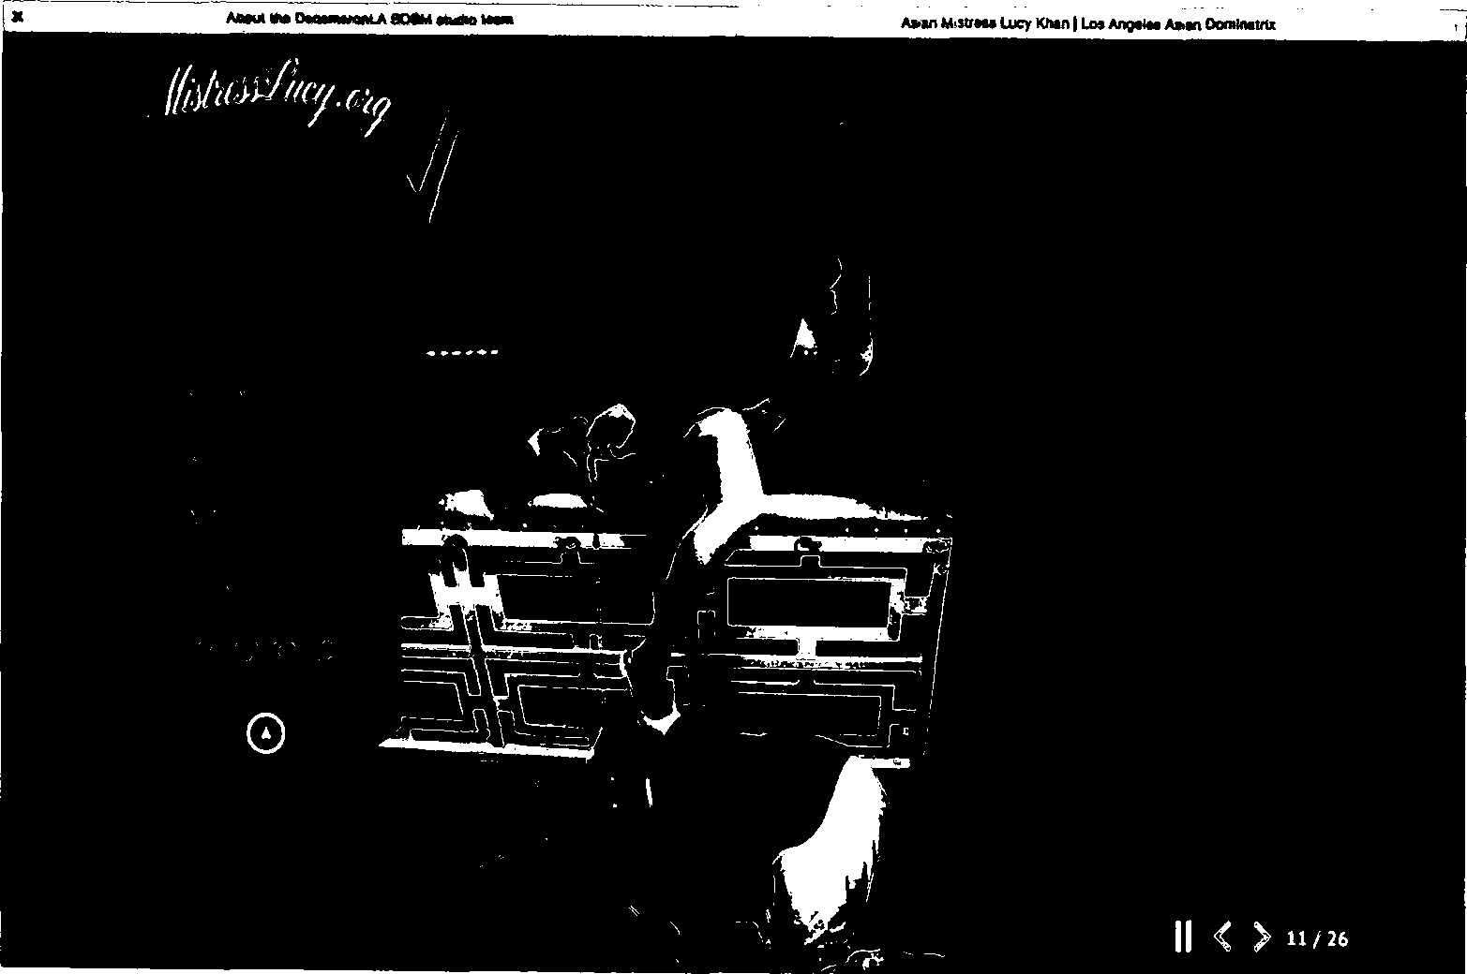[·-·

1. On or about 2014, after Mistress - moved into the Top Apartment, she began to operate a BDSM hotel business (the "BDSM Hotel," or the "BDSM Business") in the Top Apartment.
2. "BDSM" is defined as "Bondage, Discipline (or domination), Sadism, and Masochism (as a type of sexual practice)." It is a form of erotic sexual behavior among individuals.
3. Mistress - operates, and all times relevant herein has operated, her BDSM Hotel under the tradename and advertises her business on the website

as "-" currently for three

hundred and seventy-four dollars ($374) per night. The name "-" is a reference to the collection of erotic and tragic novellas by the 14th Century Italian author Giov-i Boccaccio, inspired in part by Dante's Inferno from the Divine Comedy from earlier in the 14th Century.

1. Mistress - also advertises - on the social media platform lnstagram, and maintains her own websites for her BDSM Hotel at [-](http://www.decameronla.com/) and for her prostitution services at [-](http://www.MistressLucy.org/) Within the various websites, there are hyperlinks to various pornographic still and video images wherein Mistress - engages in vulgar sex acts with multiple men and women.

.,. 26

*r-..*

::..

f-.•• 27

.•..,

) • •

( :

* *r*

,i:.:,:.--.::

1 **.Uw BOOlllll>dlo-**

2

3

4

5

6

7

8

9

10

11

12

13

14

15

16

17

18

19

20

21

22

23

24

25

l +

...... 26

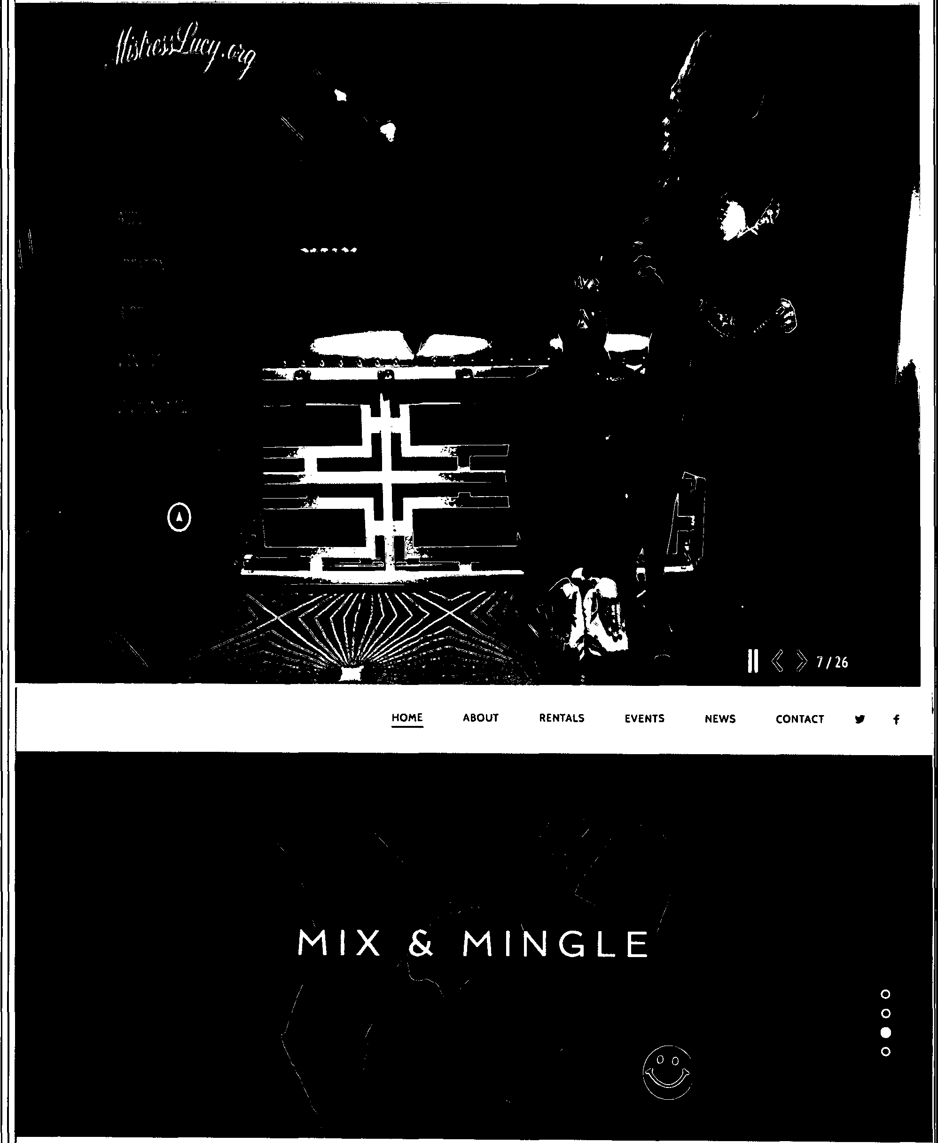

I•···

c.c:

27

•·-·

,.

1 ••••• AT&T M-Cell

9:07 PM

Gt 71"111)

2

<

# -themistress

3

....

4 84

5 posts

## 1,330 392

###### followers fallowing

6 [ JG

7

8 v - -v

#### 9 0 Los Angeles *b* Athletic Asian

10

11

12

13

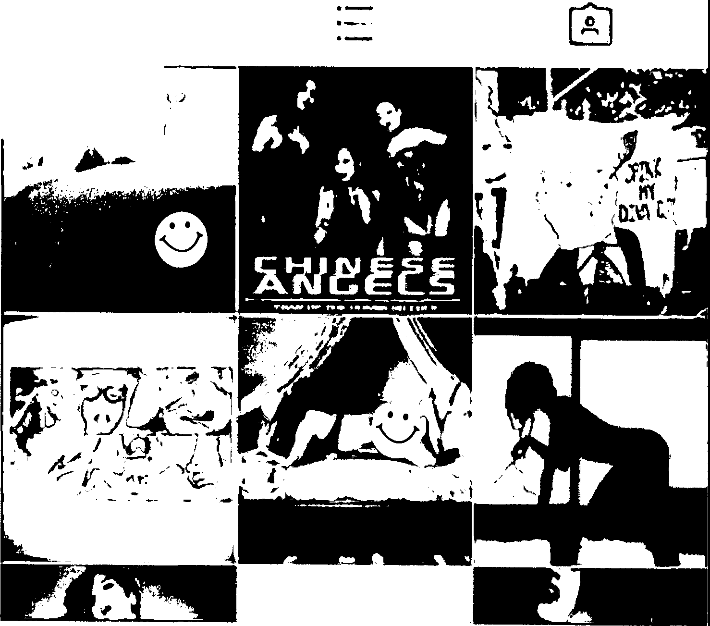

'

·

...

• • •

*!,/I* ....

l

'

'.

*J*

14

15 ,

16

17

18

19

20

21

22

23

24

c :

*u·*

Dominatrix O <http://amzn.to/1TXZhye>

BOOKINGS \

#### [www.Mistress-.org/](http://www.MistressLucy.org/)

:,. 25

< :

I.....

.,. 26

t•--

=:

i-•· 27

-.....

28

Q (±) 0

•

1

2

3

4

5

6

7

8

9

10

11

12

13

14

15

16

17

18

19

20

21

22

23

-: : 24

*.r*

25

,,,

r.c:

j,,-•

,,,

26

t•,.

<:c:

- 27

*1'"'*

....

28

_ ••••• **AT&T M-Cell. 8:19 PM**

. < **Photo**

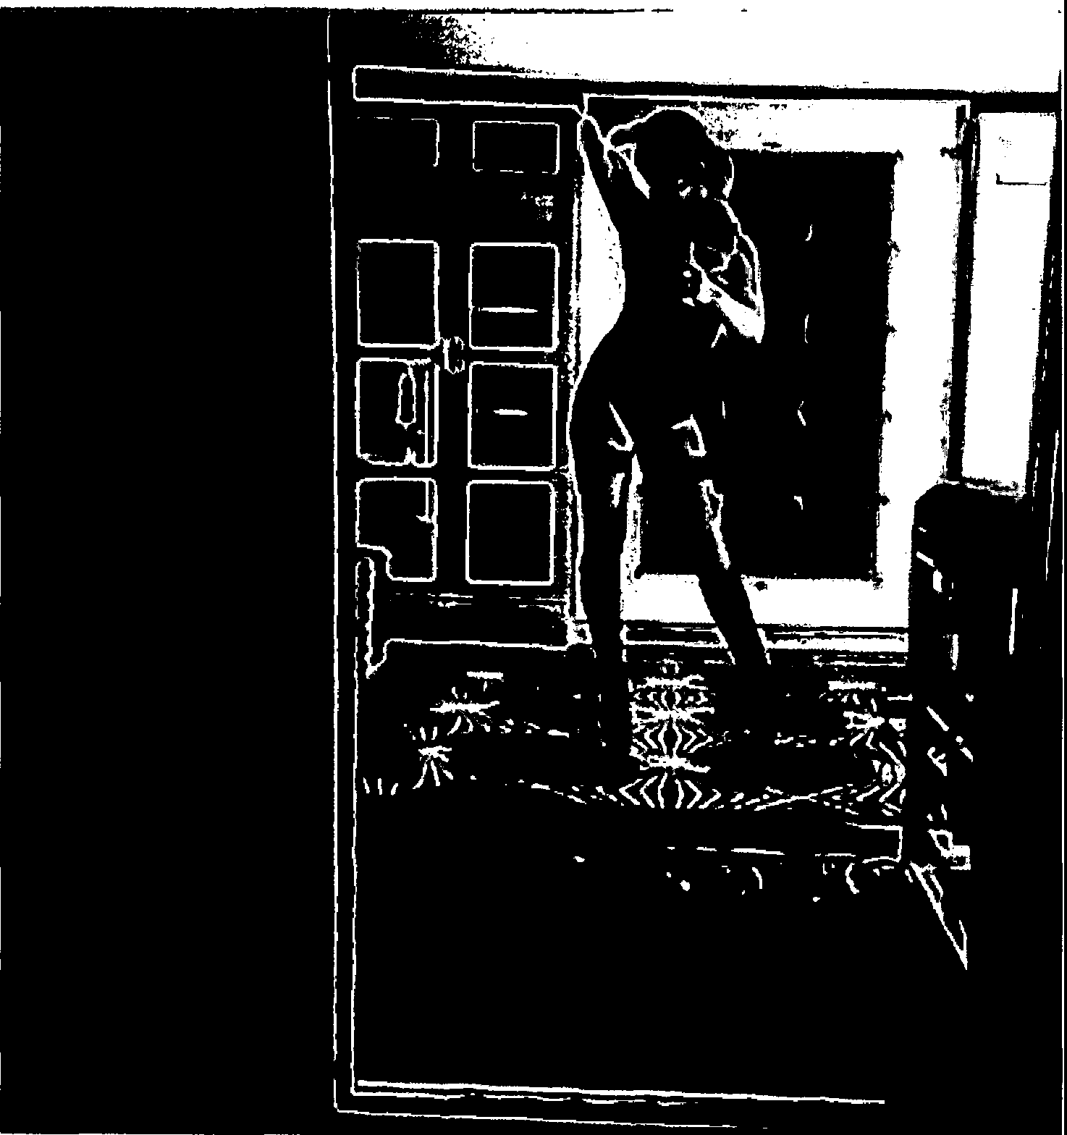**e -thE**



**76 likes**

**I'm feelin Myself... #dungeon #losangeles- #asiangir1**



**Q**

0

•



••-•

1

2

3

4

5

6

7

8

9

10

11

12

13

14

15

16

17

18

19

20

21

22

23

24

*c. :*

*,r*

••••• **AT&T M-Cell a:19 PM**

< **Photo**

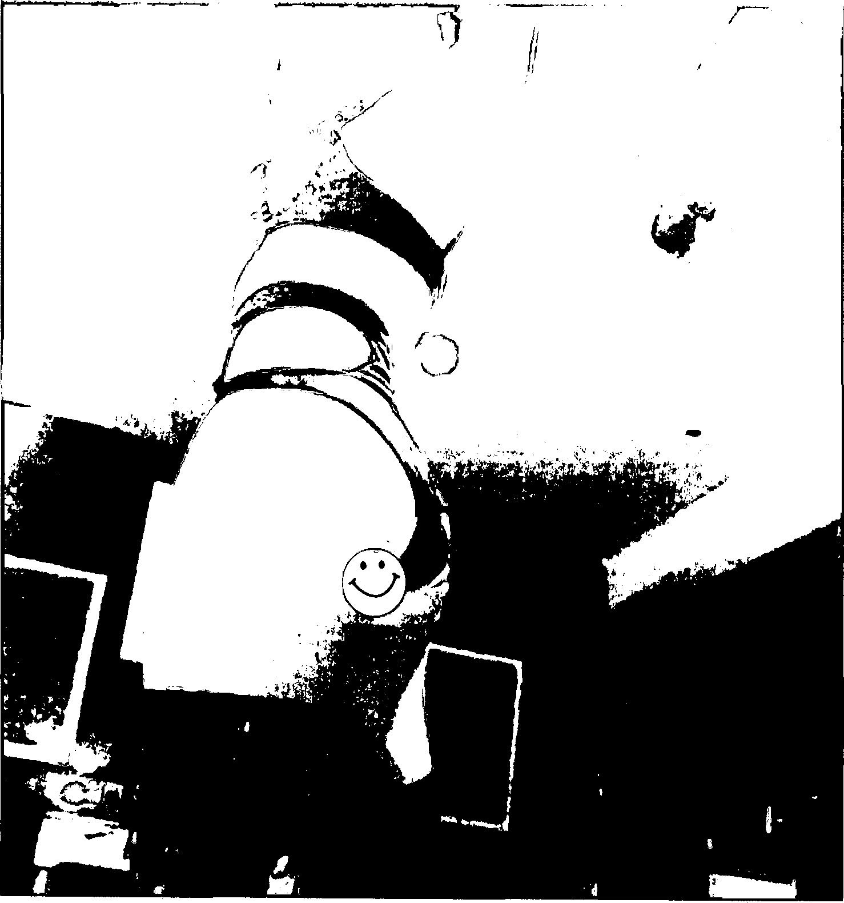@ -the



### 161 likes

##### -the #femdom #ass

***t* 92%11111)**

•••

:,. 25

.,.:..:

,... 26

r-,..

:: 27

-- .

**#legsf"ordays #thighhighboots #bootfetish**

# **A** ,.1..-."' # **A i"'ll"'h""+-'-' ,#.n""""i +ri"**

**Q** CB Q

28 •

1 ••••• AT&T M-Cell '-5=' 8:30 PM

<

2 Photo

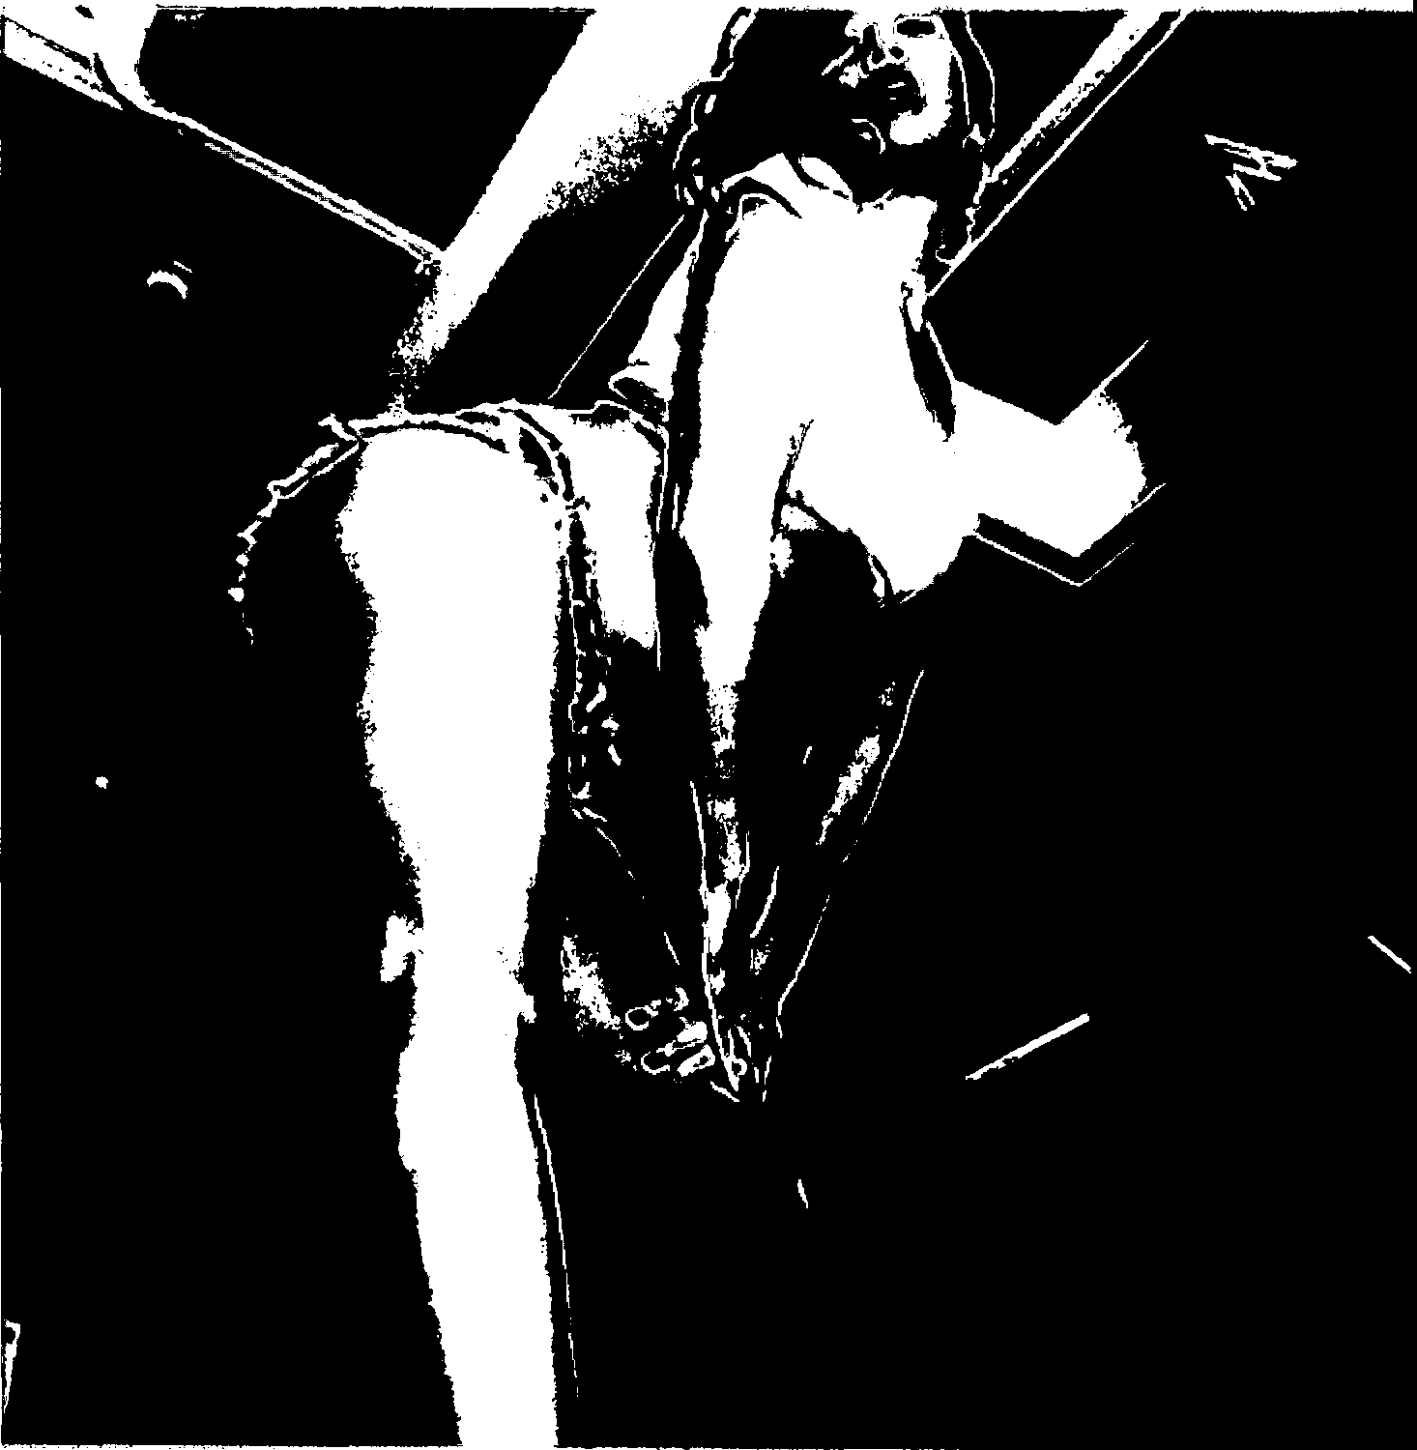3

4

5

6

7

8

9

10

t **89"111}**

*C*

11

12

13

14

15

16

17

18

19

20

21

22

23

24

c: :

1.. r

.... 25

,:c:

t•'"''

.,, 26

t•,,

..;..: 27

,.

oov

89 likes

-the #legworship Wednesday! Farmer's daughter is getting. Her•s this **time 9**

#### View all 3 comments

MARCH 1

Q (B

28 •

1 ••••o AT&T M•Cell l **8:34 PM**

2

<

# -the

3

# 4 76 1,066

•••

## 335

5 posts followers

6 

7

1. Asian Mistress, *1* - -, *1*

#### QLos Angeles *b* Athletic Asian

follo ving

···:· JG

1. Dominatrix
2. BOOKfNGSl)

13

14

15

16

17

18

19

20

21

22

23

*i:c:* 24

*,...r*

...

...

...

. --

•...

25

,; :

t•··

.,,

r ....

26

....

I , T • • •

*6--*

tl1 U I

GJ 0 '1

.(.'..c.: 27 0

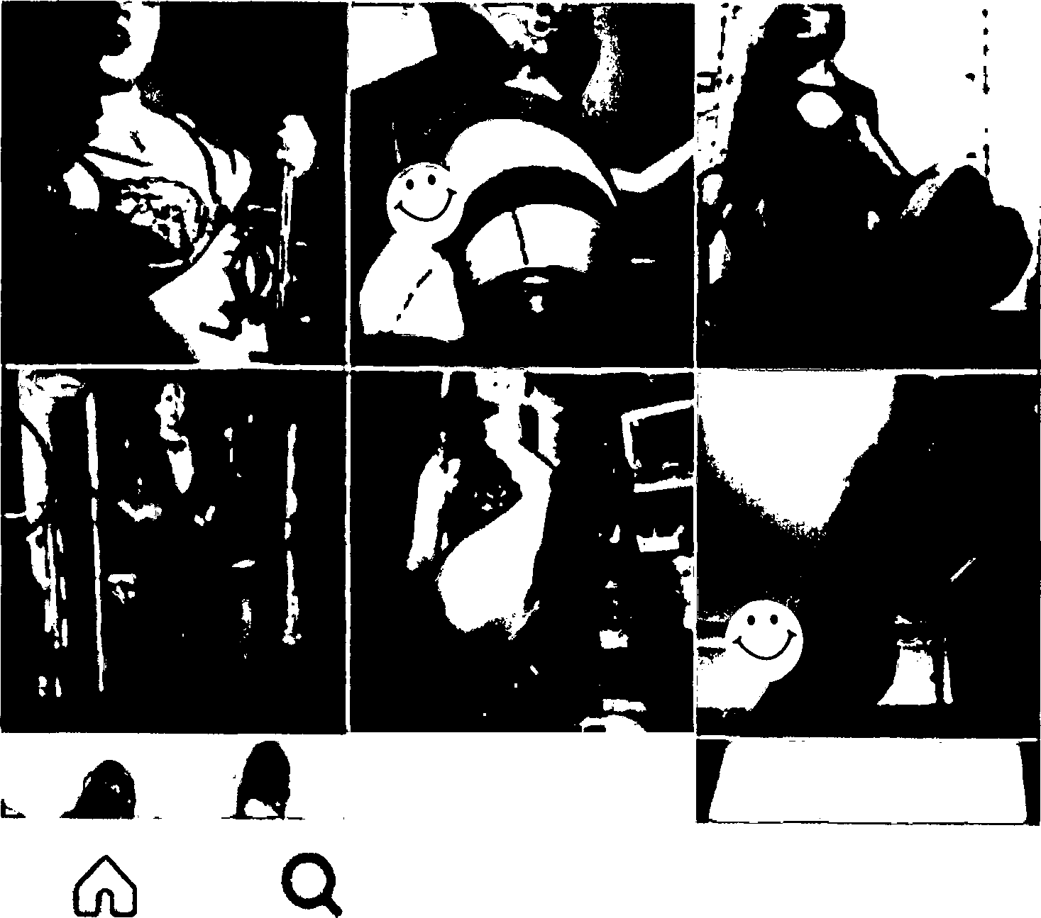

28

:t • •

1 , ••••• **AT&T M-Cell** '-:" .,• **8:21 PM**

2 . < **Photo**

3

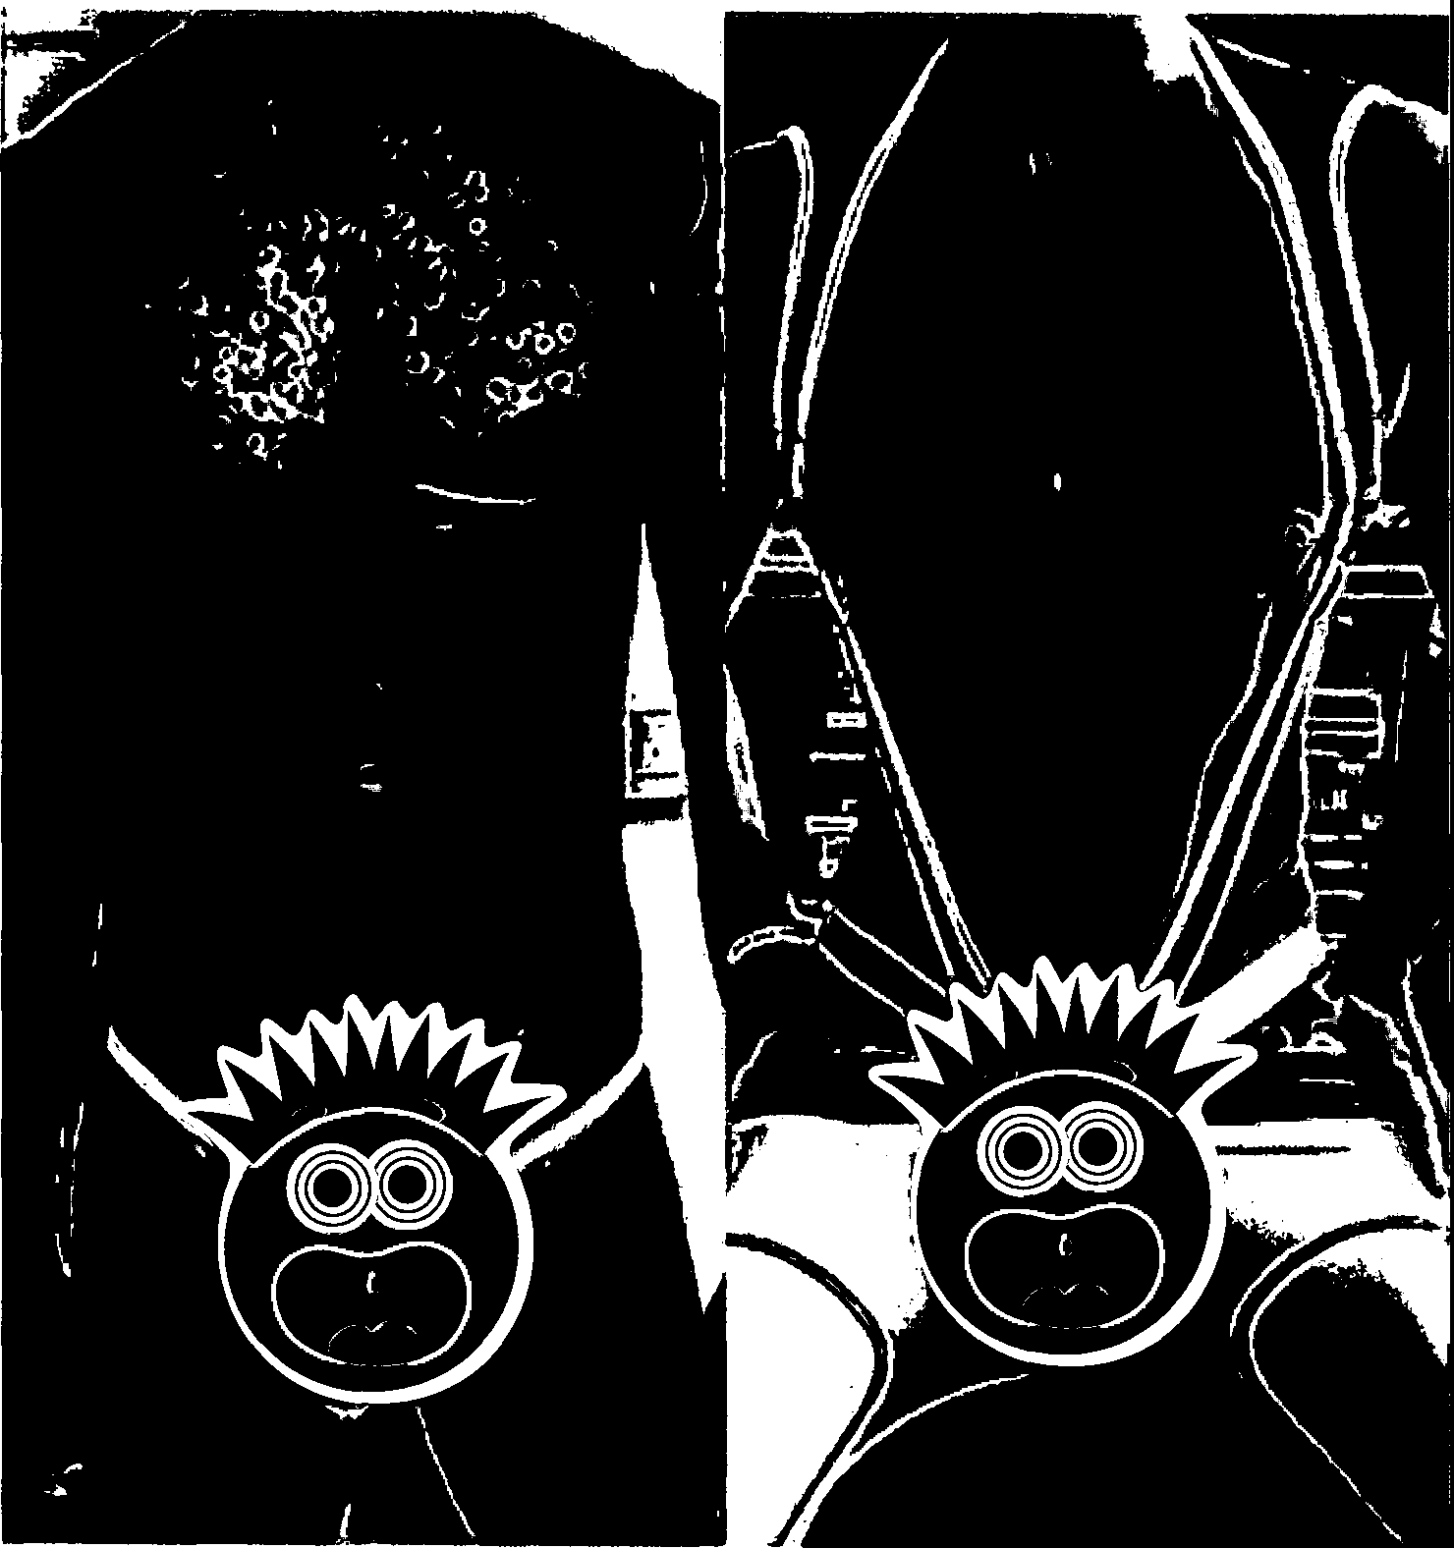4 . **e** -the

5

6

7

8

9

IO

11

12

13

14

15

16

17

**\*91%al}**

•••

18

19

20

21

22

23

24

,*(,*,*;*.*'.*

:,, 25

,: :

t.-.·.·, 26

I-,.

1-:r



**38 likes**

**-the My tomorrow night #doubfetrouble #w4mm #hotwife**



•··· 27

•

28

**Q** CB 0

I

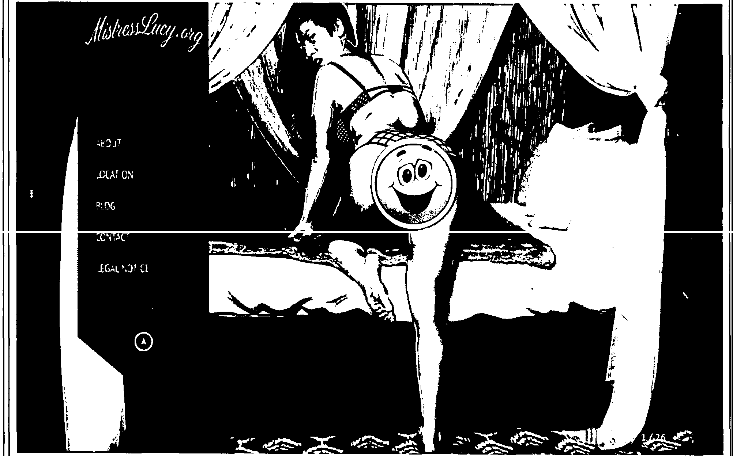

--.-

2

3

4

5

6

7

8

9

10

11

12

13

14

15

16

17

18

19

20

21

22

23

24

,(..:,·

.,, 25

,:a:

f••·

.,. 26

,

...

,: :

1---.- 27

28

1. "Landlord Defendants”, and each of them, permitted Mistress - to operate the BDSM Hotel in the Top Apartment, and have both actual and constructive knowledge of the BDSM Hotel. These Landlord Defendants knew or were willfully ignorant to the serious problems caused by the BDSM Hotel and negligently addressed or purposely failed to address each and every complaint Plaintiffs made to them regarding the BDSM Hotel. Accordingly, the Landlord Defendants' actions and inactions show that they have a clear interest in the BDSM Hotel's operation.
2. Defendants, and each of them, caused Plaintiffs, and each of them, to suffer through an unconscionable and ongoing pattern of negligent, willful, and unlawful conduct by operating and permitting the operation of the BDSM Hotel. Indeed, The BDSM Hotel subjected the entire neighborhood to humiliating, degrading, and dangerous conditions.
3. Defendants' conduct was coupled with their deleterious intent of forcing the Plaintiffs out of their Apartment, so that the Defendants could generate larger profits from their BDSM Hotel. Defendants have engaged in a vicious campaign of intimidation, physical threat of

1

2

3

4

5

6

7

8

9

10

11

12

13

14

15

16

17

18

19

20

21

22

23

i::;: 24

l .I"

25

..

(: :

(-,••

.8. 26

t····

i; :

!•·· 27

28

harm, bullying, coercion, and fraud to prevent the Plaintiffs from complaining and to further the BDSM Hotel's market outreach.

1. Defendants demonstrate their disdain and disregard for the law, public policy, and basic human rights by continuing to operate their BDSM Hotel, while employing prostitutes, and appealing to the prurient interests of their guests.
2. According to The Decameron's website and other marketing materials, the BDSM Hotel offers a "fully equipped dungeon studio, featuring a built-in suspension system, recessed ceiling mirrors, queen-sized murphy beds, an artist designed bondage bed with a cage, a padded bondage wall, a fucking machine," and a full hard-liquor bar. The BDSM Business also invites customers to enjoy their highly-priced services at any time throughout the day and night, without regard to the fact that it is located in a - with other neighbors and in the upscale residential neighborhood.
3. Defendants' conduct directly and proximately caused economic and non-economic damages to Plaintiffs. As a direct and proximate result, Plaintiffs suffered irreversible and irreparable damage. As such, Plaintiffs seek compensatory damages, consequential damages, injunctive relief, punitive damages, statutory penalties, restitution, and disgorgement for Defendants' widespread statutory and common law violations.
4. Landlord Defendants are, and at all times relevant to this action were, in the business of owning, renting, controlling, possessing, leasing, managing and/or maintaining the residential property occupied by Plaintiffs.
5. Landlord Defendants failed to meet their contractual and legal obligations to Plaintiffs by not enforcing the house rules, and allowing an obviously dangerous nuisance to be present on the Property. Indeed, there is an ongoing police investigation regarding the BDSM Hotel.
6. Plaintiffs seek damages for their injuries as well as an injunction requiring the Defendants to immediately cease the operation of the BDSM Hotel at the Top Apartment.
7. Landlord Defendants owned or operated, managed, or was responsible to maintain

the property while these unsafe and uninhabitable conditions existed and while Plaintiffs were

1

2

3

4

5

6

7

8

9

10

11

12

13

14

15

16

17

18

19

20

21

22

23

*C;c:* 24

lJ'

.,.

25

, s:

r--

26

•· .

t,.,.

r,: :

27

r•·

··· .

tenants of the property. Landlord Defendants directly, and/or through their agents, viewed these unsafe and uninhabitable conditions for themselves, and failed to abate the nuisance on the Property.

1. Notwithstanding the notification, actual knowledge, or constructive knowledge of the existence of dangerous and uninhabitable conditions on the premises as set forth in this Complaint, Landlord Defendants continued to demand payment (indeed, full payment) of rent from Plaintiffs, while allowing the operation of the BDSM Hotel on the Property.
2. Since on or about December 20, 2014, the property has not been and is not habitable or tenantable and therefore has a lesser rental value than that which is demanded.
3. Notwithstanding Defendants' knowledge that these unsafe conditions existed and were dangerous to Plaintiffs, and despite the opportunity, financial means, and legal obligation to correct these unsafe conditions, each Defendant has deliberately, wantonly and intentionally failed and refused to undertake take any significant corrective measures.

**JURISDICTION AND VENUE**

1. The Superior Court has subject matter jurisdiction by virtue of the relief sought and because the amount in controversy exceeds the jurisdictional minimum of this Court. Furthermore, this Court has personal jurisdiction over each party because each party owns or resides in real property within, or transacts a material amount of business within County. In addition, the lease agreement between Plaintiffs and Landlord Defendants was entered into and performable in County.
2. Venue is proper in County because Landlord Defendant conducts business in Los Angeles County and the subject property is located within County. Moreover, Defendants' tortious acts and statutory and common law violations were committed in County.

*Ill*

28

• •

*1*

2 Plaintiffs

PARTIES

3

4

5

6

7

8

9

10

11

12

13

14

15

16

17

18

19

20

21

22

23

�;:: 24

**l.f'**

"· 25

(..:;:...:.

·,, 26

I'-·

••·

f 27

�...

1. - is a -year-old woman, who has occupied the Apartment

since November 1, 2012 when she and her -year significant other, - -, moved into the Apartment, pursuant to the Lease agreement with Landlord Defendants and/or their predecessors in interest. Ms. - is a commercial and music video producer.

1. Unfortunately, living directly beneath the BDSM Hotel has affected Ms.

-'s overall well-being on a daily basis. The loud and morally disturbing noises Ms. - is forced to hear causes her to suffer through many sleepless nights. These disturbances range from hearing people at the BDSM Hotel scream in pain to satisfy their sexual fetishes, to hearing her doorbell ring or door knocked countless times throughout the night while the BDSM Hotel guests confuse her Apartment with the Top Apartment. The BDSM Hotel's guests have also parked in her assigned parking spot and have parked in a m-er which prevents her from leaving - with her car.

1. Due to the continuous danger posed by the guests who frequent at the BDSM Hotel and the noise emanating from the BDSM Hotel, Ms. Vanderburg is embarrassed to invite and host her friends and family at her Apartment. She is even dissuaded from having dinner with Mr. - in the comfort of their own home.
2. - - is a 47-year-old man who lives in the Apartment with his significant other, Ms. -. Mr. - works as a -. Mr. - is originally from and travels there several times each year. Since 2014 Mr. - fears leaving Ms. alone at the Apartment when he is away and has cancelled several pl-ed trips to the east coast. Mr. - has expressed his fears regarding the BDSM Hotel and the guests who frequent it countless times to Landlord Defendants. Like Ms. -, Mr. - also suffers through sleepless nights caused by the noises emanating from the BDSM Hotel, and he is in constant fear for his own safety.

*///*

28 */,'/*

**-13-** VERIFIED COMPLAINT FOR DAMAGES, DECLARATORY AND INJUNCTIVE RELIEF

**1**

2

3

4

5

6

7

8

9

10

11

12

13

14

15

16

17

18

19

20

21

22

23

(:;: 24

*v·*

25

"·

<"'''

!···

.,.

26

h,

t.:2:

27

!···

......,,.

**Defendants**

1. Plaintiffs are informed and believe, and therefore allege that Defendant **- -,** aka - T. -, aka - - - ("-") is, and at all times relevant was, an owner and/or manager of the property where the occurrences and events at issue occurred. Plaintiffs are informed and believe and therefore allege that - has been the owner or manager of the property at all times relevant, and is and was a landlord of the property, as defined by Cal. Civ. Code§ 1980.
2. Plaintiffs are informed and believe, and therefore allege that Defendantis, and at all times relevant was, an owner and/or manager of the property where the occurrences and events at issue occurred. Plaintiffs are informed and believe and therefore allege that - has been the owner or manager of the property at all times relevant, and is and was a landlord of the property, as defined by Cal. Civ. Code§ 1980.
3. Plaintiffs are informed and believe, and thereon allege that - and - are the

*alter ego* of the other.

1. - (-) E. - ("Mr. -") was the initial Trustee of the - (-) E.. The Property was owned by the late Mr. - since at least 1999, and on or about, 2002, the late Mr. - transferred the property into the - Trust. Mr. - deceased, 2015.
2. Plaintiffs are informed and believe, and thereon allege that upon Mr. -'s death, - became the successor trustee of the - Trust. Notwithstanding the fact that Mr. - was the trustee of the - Trust until his death, - and ATM still served as the Landlord, as defined by Cal. Civ. Code§ 1980, from the onset of - and tenancy at the property.
3. Plaintiffs are further informed and believe, and thereon allege that - is and was the personal representative of the decedent, Mr. -.

28

1

2

3

4

5

6

7

8

9

10

11

12

13

14

15

16

17

18

19

20

21

22

23

(;::: 24

*,..r*

",·: 25

t•"'·

.,. 26

t,_,

:;.:

t--·.· 27

28

1. Plaintiffs' causes of action against Mr. - survive his death pursuant to *inter alia* Cal. Civ. Proc. Code § 377.20. Plaintiffs are informed and believe, and thereon allege that Mr. - maintained a policy of insurance which covered and or protected his liability for the causes of action alleged herein, and Plaintiffs are further informed and believe, and thereon allege that the policy limits of the late Mr. -'s insurance policies are sufficient to cover his liability for the damages alleged herein. This action is brought against the **- Estate** within the statute of limitations as defined in *inter alia* Cal. Prob. Code § 551.
2. **- -** ("-") is the surviving widow of Mr. -, and is, and at all times relevant was, an owner and/or manager of the property where the occurrences and events at issue occurred. Plaintiffs are informed and believe and therefore allege that - has been the owner or manager of the property at all times relevant, and is and was a landlord of the property, as defined by Cal. Civ. Code§ 1980.
3. Plaintiffs are further informed and believe, and thereon allege that - is and was the personal representative of the decedent, Mr. -.
4. -, ATM, the - Estate, and - are collectively referred to herein as the Landlord Defendants.
5. Plaintiffs are therefore informed and believe, and therefore allege, that the Landlord Defendants are the current owners or managers of the property as defined by Cal. Civ. Code § 1980, and that each has acted, and they have collectively acted, in that capacity during all times relevant to this Complaint.
6. Plaintiffs are informed and believe, and therefore allege, that Defendant **-,** aka - -, aka MISTRESS - ("Mistress -" or "Tenant Defendant") is, and at all times relevant was, a tenant of the Top Apartment where the occurrences and events at issue occurred.
7. Plaintiffs are informed and believe, and based thereon allege, that at all times relevant to this Complaint, Defendants, and each of them, were acting as the agent, servant, employee, subsidiary, joint venturer, affiliate, partner, assignee, successor-in-interest, *alter ego,* or

other representative of each other, and were acting within the course and scope of their agency,

1

2

3

4

5

6

7

8

9

10

11

12

13

14

15

16

17

18

19

20

21

22

23

c: : 24

LJ'

.,. 25

*a:*

,...

26

"·

r,,.

t: :

t•-·.· 27

28

servitude, employment, subsidy, joint venture, affiliation, partnership, assignment, succession, *alter ego,* and/or representation, with the full knowledge, consent, permission, authorization and ratification, either express or implied, of each of the other Defendants in performing the acts alleged in this Complaint.

1. Plaintiffs are informed and believe, and based thereon allege, that at all times relevant to this Complaint, Defendants, and each of them, participated as members of a conspiracy and/or aided and abetted one another in furtherance of the schemes alleged herein, or assisted one another in carrying out the purpose of the conspiracy alleged herein, and have performed acts and oade statements in furtherance of the conspiracy, all in violation of both Federal and California law. Each of the Defendants acted both individually and in concert with the other Defendants with full ,.knowledge of their respective wrongful conduct. As such, the Defendants, and each of them, conspired together, building upon each other's wrongdoing, in order to accomplish the acts complained of herein. Defendants, individually, are sued as principals, participants, and/or aiders and abettors in the wrongful conduct complained of, and the liability of each arises from the fact that each has engaged in all or part of the improper acts, schemes, plans, conspiracies or transactions complained of herein.
2. Numerous individuals and separate entities, currently sued as Does, have a-:::tively participated during the course of and in furtherance of the wrongdoing alleged and

C•)mplained of herein. The individuals and entities acted pursuant to agreement and in concert with each of the other Defendants in this action, whether specifically identified by name or whether sued under a fictitious name. Each has also acted as an agent for the principals, in order to advance the objectives of the conspiracy.

1. Plaintiffs are presently ignorant of the true names and capacities of Defendants sued as Does 1-10, inclusive, and therefore sue these Defendants by such fictitious names and capacities pursuant to Cal. Civ. Proc. Code § 474. Plaintiffs are informed and believe, and on this basis allege, that each fictitiously named Defendant is responsible in some m-er for the alleged acts and failures to act, and that Plaintiffs' injuries were legally and proximately caused by the

conduct of each such Defendant. Plaintiffs will seek leave of the Court to amend this Complaint

1

2

3

4

5

6

7

8

9

10

11

12

13

14

15

16

17

18

19

20

21

22

23

,;;:: 24

*,..r*

c":·: 25

i--·

- . 26

,"":"r'

i---.· 27

to allege the true identities of these fictitiously named Defendants, once their names and capacities are ascertained. Plaintiffs will also seek leave of the Court to amend this Complaint to allege with further specificity the m-er in which each fictitiously named Defendant is responsible for the damages sustained by Plaintiffs.

**ALLEGATIONS COMMON TO ALL CAUSES OF ACTION**

1. Plaintiffs repeat, reallege, and incorporate by reference every allegation contained in the preceding paragraphs as though each were fully set forth in this paragraph.
2. Defendants were and/or are responsible for and liable to Plaintiffs for the events, happenings, and damages hereinafter set forth herein.
3. In committing the unlawful and wrongful acts as alleged herein, Defendants pl-ed and participated in and furthered a common scheme by means of harassing, vexing, -oying, pestering, hassling, worrying, stalking, damaging, disturbing, distressing, and otherwise bothering Plaintiffs. In particular, Defendants are operating an illegal business at the Top Apartment wherein the apartment has been converted into a sexual dungeon, and is offering the services of various female prostitutes, including Mistress -, who engage in the sexual fetish of bondage, discipline, sadism, and masochism and wherein female dominants brutalize and torture submissive males. (the "BDSM Hotel"). Dozens of people frequent the BDSM Hotel day and night on a regular basis, and Plaintiffs are constantly disturbed by the BDSM Hotel and fear for their own safety and wellbeing.
4. Defendants generate large profits from operating the BDSM Hotel in the Top Apartment, and have utilized every means necessary to cause or otherwise inveigle Plaintiffs to surrender possession of their Apartment so they can expand the BDSM Hotel.
5. Despite the dangers imposed and damages caused to Plaintiffs (and the entire neighborhood) by Defendants' operation of the BDSM Hotel, all of which constitute a veritable cornucopia of breaches of the Lease and common decency, Landlord Defendants nonetheless have

demanded, and indeed continue to demand that Plaintiffs pay their rent in full.

1. 49. In committing the unlawful and otherwise wrongful acts as alleged herein,
2. Defendants have pl-ed and have participated in, and have otherwise furthered a common
3. scheme, by means of endangering Plaintiffs and causing both a private and public nuisance on the
4. Property. In particular, Defendants have failed to keep the property up to the minimum standards
5. defined in *inter alia* in Health & Safety Code § 17920.3 (c). Defendants knew or should have
6. known that creating and harboring a nuisance would violate California law. Defendants further
7. aided and abetted and knowingly assisted and conspired with each other in breach of their
8. respective duties as alleged herein.
9. 50. Defendants' conduct during Plaintiffs' tenancy at the Property is in clear violation of
10. the habitability laws and standards contained in Civil Code, Health and
11. Safety Code, Public Health Code, Municipal Code, and
12. the and Code.
13. 51. Below is a brief description of the history of Defendants' widespread unlawful,
14. repugnant, and malicious conduct; then followed by the various causes of action that Plaintiffs
15. now asserts based upon the most recent and current actions and inactions of these Defendants. 16
16. **CHARACTERISTICS OF THE NEIGHBORHOOD**
17. 52. As described in detail below, the nature of the nuisance is even more troubling due
18. to the effect it has on the entire neighborhood. The Duplex is located in what is considered the
19. -a neighborhood that houses many families with young children.
20. Shockingly, in Defendants' marketing materials, they actually have the audacity to tout that they
21. are "discreetly housed in an upscale neighborhood in the heart of- "
22. 23

24

( :

**l r**

....

25

t:;::

-·

.,. 26

--·

*<. :*

.....

27

.....

1

2

3

4

5 1H1:x1 lloire

##### 6 O°"dR SPACE

7 *

HOME

ABOUT RENTALS EVENTS NEWS CONTACT .,, f

8

9

10

11

12

13

14

15

16

17

18

19

20

21

22

23

c: : 24

*'· r*

25

.(.,:..:

As I.A's newest private adult playspace. The is a one-of-a­ kind BDSM studio available for private and event rentals. Our intimate studio is a 400 sqlt. professionally soundproofed space with a 400 sqlt private outdoor patio. Our patio area is fully-enclosed and features an outdoor soaking tub & canopy bed for a luxurious and relaxing experience. Discreetly housed in an upscale neighbomood in the heart of Los Angeles, our fully-equipped contemporary dungeon facility has all you need to make any fantasy come to Ufe.

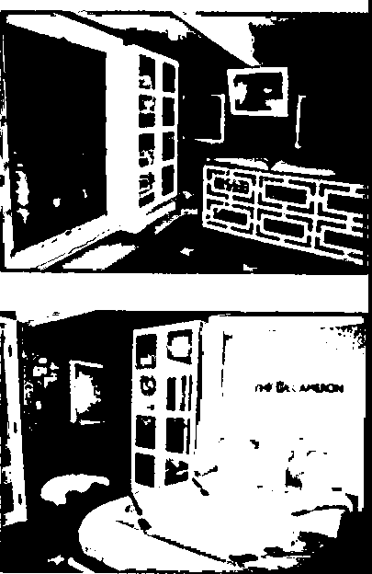DE RENTALS

HOME ABOUT RENTALS EVENTS NEWS CONTACT .,, f

Me *is* a *contemparory dungeon facility that is located inane of LA'.s most desirable neighborhoods. All private rentals indude* access *to our extensive collection of toys* and *equipment. For first time rentals, a representative will be pll!Sent to help acquaint you with* our *space and show you all the amenities our space has to offer.We provide full cleaning service at the end of your stay, so you can concentrate on the* ***good*** *stuff!*



·· . 26



11

h-

(.":

- 27

11

-·

....

**1**

2

3

4

5

6

7

8

9

10

11

12

13

14

15

16

17

18

19

20

21

22

23

24

(:;,:.

"·

..

25

r.: :

,..

26

"·

t-,.,

<:,:

,"I'... 27

28

1. The Duplex is located close to; and other locations which are frequented by children and families.
2. Several neighbors other than - and - have complained to authorities, including, but not limited to, the Police Department and the Housing Department about the danger caused by the BDSM Hotel. Indeed, the Plaintiff are informed and believe, and thereon allege that there is currently an investigation by the LAPD regarding the BDSM Hotel.

**CONSTRUCTION OF THE BDSM HOTEL**

1. The construction of the BDSM Hotel began on or about 2014, after the previous tenant of the Top Apartment vacated. Defendants completed the significant amount of construction required to convert a residential apartment into a sex dungeon approximately five (5) weeks later (the "Construction Period"), and did so without pulling any of the required construction permits from the Building and Safety ("DBS").
2. During the Construction Period, - and - suffered the following as a result of Defendants' construction: (1) constant noises from hammering and general constriction work;
3. thick dust throughout the Duplex; and (3) blocking of Plaintiffs' parking spaces and driveway by construction workers. Indeed, Defendants did not offer or provide any accommodations, support, or assistance to - and - during the Construction Period.
4. During the Construction Period, - and - noticed and informed Landlord Defendants of strange furniture and other items that were being brought up to the Top Apartment. Some of the furniture - and - identified in their communications to the Landlord Defendants were: (1) a portable pool; (2) a uniquely large bathtub; (3) a metal cage large enough to hold human beings and/ or large animals; (4) bar tables; and (5) a rounded frame with an accompanying round mattress.

*Ill*

*/II*

*/fl*

* 1. **THE BDSM HOTEL'S SERVICES**
  2. 58. After the Construction Period, the BDSM Hotel was fully functional and

3

4

5

6

7

8

9

10

11

12

13

14

15

16

17

18

19

20

21

22

23

<,".' 24

*r*

<"·: 25

**f,•-·**

,,. 26

f'·-·

,; :

27

1---

..... .

immediately attracted many guests.

1. Although the BDSM Hotel serves food and alcoholic beverages to its guests, it does not have a valid permit to operate as a restaurant or to serve alcoholic beverages. Indeed, Defendants failed to obtain the proper business licenses (or any business licenses at all) for the operation of their BDSM Hotel.
2. According to Defendants' own marketing materials, the BDSM Hotel is composed of four (4) sections: The Main Salon, The Formal Dining Room, The BDSM Studio, and The Rooftop Oasis.
3. According to Defendants' own marketing materials, the BDSM Hotel offers the following amenities:
   1. Artist-designed bondage bed with cage;
   2. Custom padded bondage wall;
   3. Electrical suspension winch;
   4. Fetish fantasy swing;
   5. Queen-size murphy bed with restraint system;
   6. Impact toys;
   7. Lather harnesses and restraints;
   8. · Stainless steel shackles;

1. Hand-held and stand-alone love machines;

J. Gags and attachments;

1. Electro-play sets;
   1. Hoods and masks;
2. Body bag and chastity devices;
3. Absorbent pads and drop-cloths;
4. Toy covers and prophylactics;

28 p. Personal lubricant;

|  |  |  |
| --- | --- | --- |
| 1 | q. | Cleaning supplies; |
| 2 | r. | iPad controlled stereo system; |
| 3 | s. | A/C and heat; |
| 4 | t. | Ceiling mounted mirrors; |
| 5 | u. | Semi-transparent latex curtains; |
| 6 | **V.** | Two (2) designated parking spaces; |
| 7 | w. | Private fully enclosed patio; |
| 8 | **X.** | Outdoor rooftop soaking tub; |
| 9 | y. | Outdoor canopy bed; and |
| 10 | z. | Custom adjustable spanking horse |
| 11 |  |  |

12

13

14

15

16

17

18

19

20

21

22

23

24

*! [:*

*,.,r*

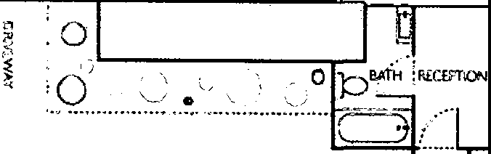

,,n,o:o

......,,....., ...... ,,. ....... _r·., ,_

P,,.llO

0j •

HOME



ABOUT RENTALS EVENTS **NEWS** CONTACT ***'I* f**

..

..

..

...

..

liifilID ..

..

..

..

..

..

..

..

..

..

..

..

..

..

..

..

..

..

"· 25

.<..:..:

26

•..,

,-.....

(: :

27

.....

.....

1. According to Defendants' own marketing materials, The BDSM Hotel offers four

(4) packages: (1) The "QUICK ESCAPE," which is a two (2) hour package that costs one hundred

28 and eighty dollars ($180). It offers a "quick and dirty escape from the monotonous rituals of daily

1. life. Includes access to our extensive collection oftoys and equipment"; (2) The "EXTENDED
2. QUICK ESCAPE," which is a four (4) hour package that costs two hundred and eighty dollars
3. ($280). It offers the same services as the "QUICK ESCAPE" but for an extended period of four
4. (4) hours; (3) The "DELUX [sic] OVERNIGHT RETREAT," which is a fourteen (14) hour
5. package that costs three hundred and fifty dollars ($350). This package required guests to check­
6. in at 8 p.m., and check-out by 10 a.m., and includes a "complimentary continental breakfast"; and
7. (4) The "PREMIUM 2-DAY GATEWAY," which is a forty-five (45) hour package that costs six
8. hundred dollars ($600). The BDSM Hotel described the package as "a spectacular gateway that
9. you will be sure to remember. This is the perfect package for your -iversary, birthday, or a
10. special vacation. With so many chic restaurants, spas, and shops within walking distance, you
11. will be sure to have the experience of a life time. Check-in is at 2pm and check-out by 11am.
12. Continental breakfast and special care basket included." 13 -

**HOME ABOUT**

14

**PRIVATE DUNGEON PACKAGES**

15

16

A QUICK ESCAPE

RENTALS EVENTS

NEWS CONTACT **W f**

**$180**

2 hours I Plan a quidc and dirty escape from the monotonous rituals of daily Life. Includes access to our extensive collection of toys and equipment!

17

EXTENDED QUICK ESCAPE

18 **4** hoursI Sometimes two hours just isn't enough! Make it 4 hours to ensure that your experience doesn't get cut short.

RECOMMENDED

DELUX OVERNIGI-IT RETREAT **$350**

**14** hours I Take the time to fully immerse yourself in your fantasy. Take advantage of all that isavailable to you. including our relaxing patio lounge with canopy bed! Check-in at 8pm and check-out by 10am, after a compUmentary continental breakfasd

19

20

21

PREMIUM 2-DAY GETAWAY

**$280**

**$600**

**45** hours I A spectaOJlar getaway that you will **be** sure to rememberl This is the perfect padcage for your -iversary, birthday, or a special vacation. With so many chic

22

restaurants. spas.and shops within walking distance. you will be sure to have an experience of a Lifetime. Check-in at 2pm and check-out by11am, continental breakfast and special care basket Included!

23

MENTORING ADD-ON

,: : 24

ADD A 30 MIN CONSULTATION

**$100**

l,1'

.,, 25

,::::

t·•·

·· . 26

r•,.

r

.... 27

9 ....

Enhance your experience by allowing Professional Dominatrix - or Iris to"show you the ropes" and help you get Inspired for your stay! Compatible with any package, with longer sessions available upon request.

1



2

3

4

5

6

7

8

9

10

**11**

12

13

14

15

16

17

18

19

20

21

22

23

24

r.: :

l.J"

·· . 25

..

**c: :**

,.

"· 26

**t** ....

,:; :

f• 27

1. Defendants make the following disclosure on some of their marketing materials: "Please note that like boutique hotels, we do require a credit card on file in order to make your reservation. Thanks for your understanding."
2. Troublingly, if a guest's credit card is declined, - immediately shames that guest on her social media accounts, by posting the guest's full name, picture, and credit card information for her followers to see. Indeed, in a shocking violation of both state and federal law, Mistress - has posted photographs of full drivers' licenses and credit cards belong to people who had the misfortune (or perhaps the fortune) of having their credit cards declined by the issuing bank for the purchase of Mistress -'s and the BDSM Hotel's services.
3. Mistress - invites her online followers to enjoy her services as an Asian Female Dominatrix in the BDSM Hotel. Indeed, in one of many photographs posted on her online piatforms, Mistress - holds the penises of two males with both of her hands, while they are restrained with handcuffs to the ceiling. The photograph is followed with the caption: "W-a be my personal slave? Get a taste of it here, loser." This photograph, along with many other similar

photographs, were taken inside the Top Apartment.

1

2

3

4

5

6

7

8

9

10

11

12

13

14

15

16

17

18

19

20

21

22

23

,:r 24

l I'

.,, 25

i; :

r••..·. 26

h,

: :

27

'-"."..".'.'

'

1. - and - informed Landlord Defendant of the BDSM Hotel's marketing materials, including but not limited to printed materials, as early as 2015. However, Landlord Defendants ignored - and -, and have refused to address this issue till this



,

28 day.

1

2

3

4

5

6

7

8

9

10

11

12

13

14

15

16

17

18

19

20

21

22

23

i:c: 24

J.,f'

.,. 25

<: :

!••·

.,. 26

"-·

**THE BDSM HOTEL OPENS TO THE PUBLIC**

1. On or about 2015, Defendants officially opened the BDSM Hotel. Instantly, there was an increase of traffic on and around the Property, consisting of guests visiting and staying overnight at the BDSM Hotel. The traffic was ongoing throughout all hours of the day and night. Indeed, the BDSM Hotel is open 24 hours a day, 7 days a week, and offers rentals of two (2) and four (4) hour increments, and per its own marketing materials, the BDSM Hotel requires that overnight guests check-in at 8:00 p.m., and check-out the following morning at 10:00 a.m.
2. The BDSM Hotel employs at least three (3) regular prostitutes, a dozen of temporary prostitutes, and other personnel, such as bartenders, servants, and a marketing director named Sonya. The three (3) regular prostitutes reside at the Top Apartment.
3. What started with a shocking 10-15 guests frequenting the BDSM Hotel, has blossomed into an ongoing nightmare of people - many dressed in leather fetishware and many in various states of undress - coming in and out of the BDSM Hotel 24-hours a day. On certain days, the BDSM Hotel has hosted and still hosts over fifty (50) different people.
4. In order to get to the BDSM Hotel, each guest and employee must walk past Plaintiffs' front door. Almost every single day and night, the BDSM Hotel's guests ring Plaintiffs' doorbell and/or knock on their door, apparently believing that the BDSM Hotel is also located in the Plaintiffs' Apartment.
5. The prostitutes and mistresses that work at the BDSM Hotel wear high-heeled shoes, which can be heard when they go up to the BDSM Hotel through the staircase, or while they are "working" in the BDSM Hotel.
6. The BDSM Hotel promotes *satisfaction through pain and humiliation.* Indeed, the BDSM Hotel states on its own social media and other marketing platforms that the BDSM Hotel is "perfect for socializing and play such as foot worship, OTK [over-the-knee spanking], domestic

role play, tease and denial, and group humiliation/training scenes."

,..:..

-·

..... 27

I 73. Almost every

1. night since the BDSM Hotel
2. opened, - and - are
3. disturbed and frightened by
4. loud noise of people screaming
5. in pain from being physically
6. abused, including having large
7. latex "sex toys" and other
8. objects forcibly shoved into IO various orifices of their body
9. including their anuses, and
10. others (and perhaps some of
11. the same victims) being caged,
12. whipped, restrained with
13. chains, humiliated, and
14. spanked by the mistresses and
15. prostitutes employed by the
16. BDSM Hotel. 19

••••• **AT&T M-Cell 9**

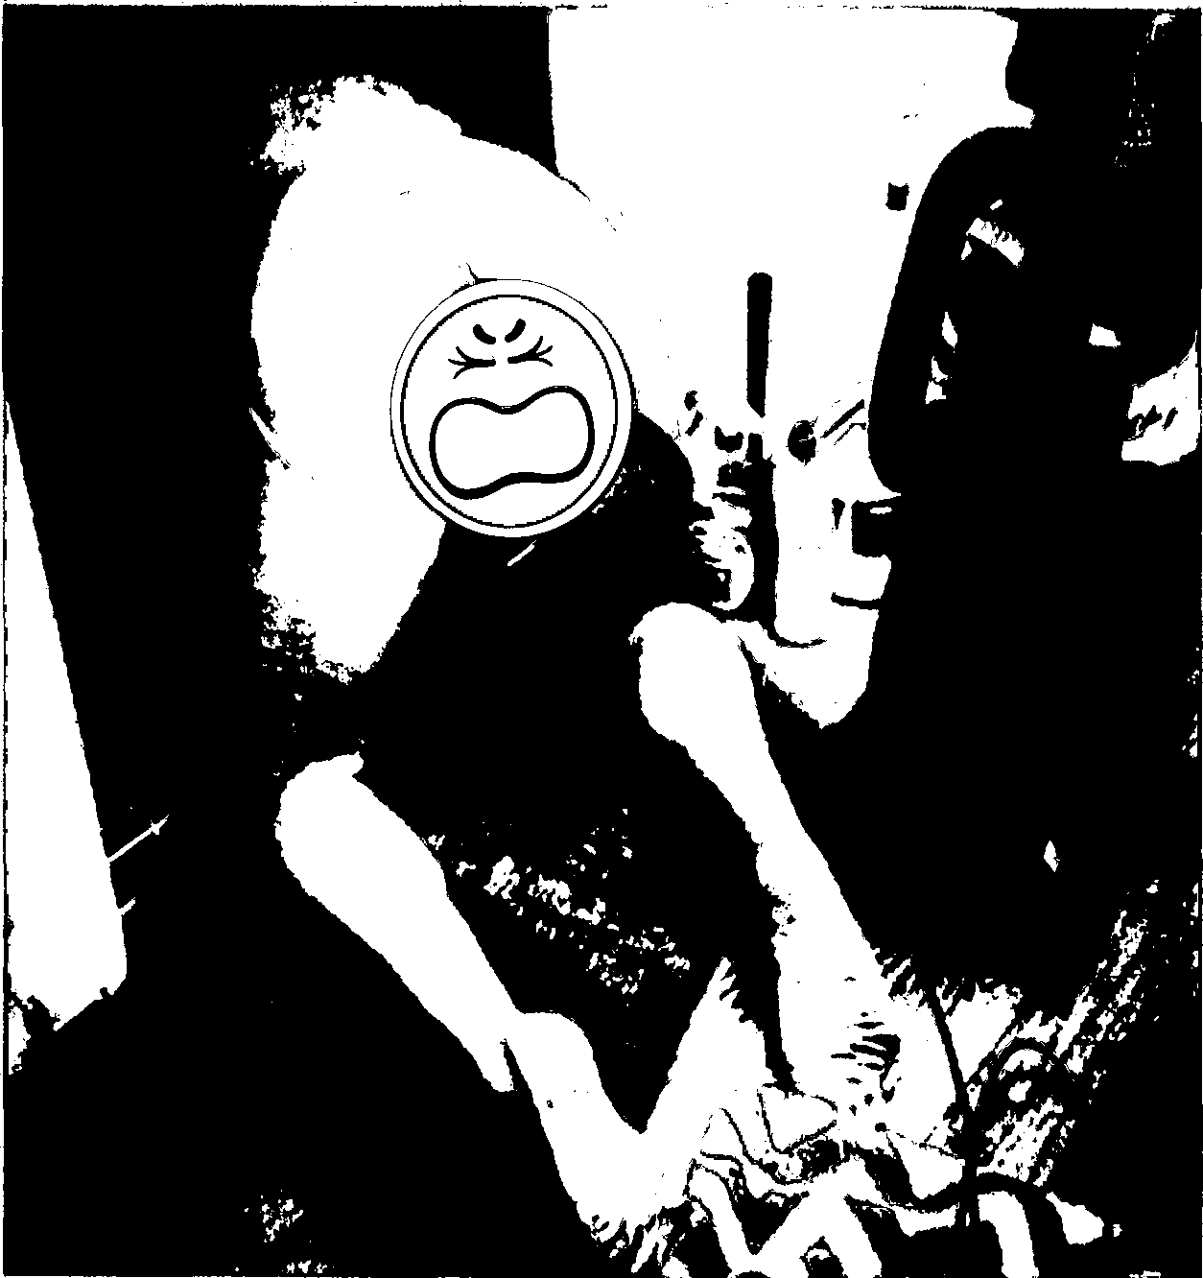<

oov

**78 likes**

**8:17PM**

### Photo

t **92%11111)**

G

**-** My favorite sexual

20 position v

###### 21 View all 4 comments

22 **2016**

23

**Q** G 0

24

.,. 25

"· 26

.... 27

* '""'

1

2

3

4

5

6

7

8

9

10

**11**

12

13

14

15

16

17

18

19

20

21

22

23

(: : 24

.

*(1'*

..,, 25

**c: :**

t•--

.,. 26

"-·

c.c:

t·--.· 27

28

1. On many nights, the BDSM Hotel reaches its maximum capacity, which requires giests to wait in the common area of the Duplex for their turn to enter the BDSM Hotel. Guests waiting for their turn are often loud, intoxicated, smoke cigarettes and marijuana, and litter the Property with cigarettes butts, empty bottles of liquor, plastic cups, condoms, and other items.
2. Illegal drugs are often consumed in the Duplex by guests of the BDSM Hotel and customers of Mistress -'s prostitution services. Indeed, on or about, 2015, - observed Grace Marie, then one of the residents of the Top Apartment and a guest snorting cocaine right outside - and -'s back door.
3. - and -'s assigned trash bins are often filled with wholesale quantity of e:npty boxes of condoms, and empty boxes and bottles of sexual lubricants from the Top Apartment.
4. As early as 2015, - and - made official complaints to Landlord Defendant about the BDSM Hotel, both orally and in writing. Every time one or both of the Plaintiffs complained about the noise and illegal activity at the Top Apartment, they were either c,::,mpletely dismissed by the Landlord Defendants or were asked to be patient - just one of the many examples (as more fully described hereinbelow) evidencing that the Landlord Defendants were very much aware of the depraved, vulgar, and wildly illegal conduct at and surrounding the Top Apartment and the BDSM Hotel.

**SEX PARTIES AT THE BDSM HOTEL GO OUT OF CONTROL**

1. As of 2015, the BDSM Hotel began to host sex parties, in which dozens of guests attended and caused severe disturbances to - and - and to the entire neighborhood. Being right underneath these sex parties, - and - suffered tremendously and were unable to sleep. - and - made countless complaints to Landlord Defendants and to Mistress -, but each complaint was completely ignored and dismissed. Even when there was no sex party, there were still many guests visiting, staying, and living at the BDSM Hotel, which made and continues to make it impossible for - and - to have even a

single quiet evening at their own Apartment.

1

2

3

4

5

6

7

8

9

10

11

12

13

14

**15**

16

17

18

19

20

21

22

23

24

t;:::

*l*.*.*.*,*.*r* **25**

,

c:;:

,-..·.. 26

t,,.

(:-:-:· 27

.......

1. On or about 2015, Defendants promoted and hosted at the BDSM Hotel a sex party in which over 50 people attended. - and -'s doorbell rang by guests at least 40 times that night. The BDSM Hotel guests parked on the Property and completely blocked the driveway.
2. At around 12:00 a.m., a fight broke out at the sex party. The fight involved over 20 intoxicated men. The fight was so disturbing that it caused other neighbors to come out of their 1omes in the middle of the night and call the police. The police handcuffed and detained multiple guests that night.
3. On or about 2015, Defendants promoted and hosted another sex party at the BDSM Hotel. This time, the BDSM Hotel served alcohol. Again, like in the sex party that occurred just a few days prior, - and - again heard the discomforting and disturbing sounds of the BDSM Hotel's guests: (1) screaming and writhing in pain; (2) being forcibly and violently spanked; (3) having various types of sexual intercourse; and (4) yelling profane, inappropriate, humiliating, degrading, and slave-oriented words, all night long. This noise prevented them from what was their seventh consecutive night without sleep, all caused by Defendants' operation of the BDSM Hotel.
4. These sex parties proved to be very profitable to Defendants, which motivated Defendants to host yet another sex party at the BDSM Hotel on 2015. Like the other sex parties, dozens of people attended this party and were once again a great disturbance not only to the Plaintiffs, but to the entire neighborhood as well. Defendants promoted and hosted several other sex and torture parties throughout the year of 2015.
5. On or about 2016, the BDSM Hotel promoted and hosted a Chinese New Year Party, whereby the BDSM invited its Guests to enjoy the services of ten (10) Asian dominatrices. Once again, the PD was called to respond to various neighborhood complaints around midnight when the sex and torture party went out of control. Plaintiffs and the entire neighborhood were bothered by the noise that night and were unable to sleep.
6. On 2016, due to multiple neighbors complaining about the operation of

28 the BDSM Hotel at the Duplex, the LAPD conducted an investigative meeting with the neighbors.

1. The investigative meeting was on 2016, at 8:00 p.m., at the neighboring house of
2. on the 100 block of Avenue. Officer
3. , Sergeant and Sergeant of the
4. PD attended the meeting. This meeting was coordinated between the PD and HD.
5. 85. Defendant Landlords knew about the investigative meeting at the neighbor's house,
6. but did not attend.
7. 86. On or about

8 2016, Defendants

1. promoted and hosted another sex
2. party at the BDSM Hotel.
3. Defendants advertised the party as
4. •·3 Hours with 3 Iconic Asian
5. Mistresses," with a note to make a
6. reservation by emailing
7. [.](mailto:lucythemistress@gmail.com) The
8. three prostitutes involved in this
9. party were Mistress -,
10. 19

20

21

••••• **AT&T M•Cell -.S:-**

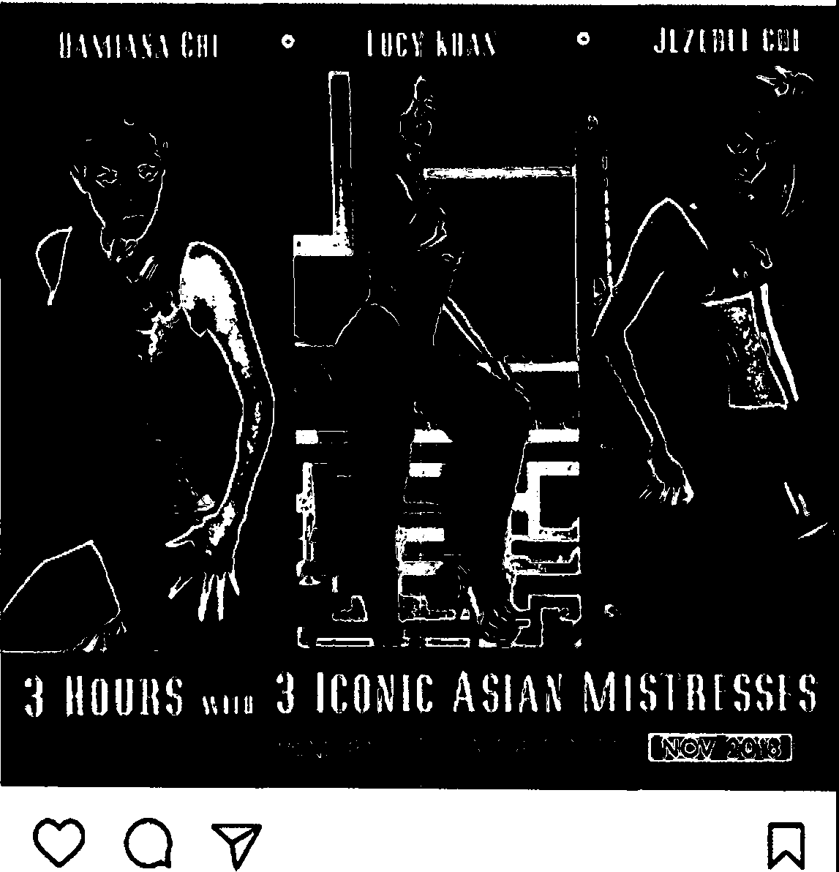<

41 likes

a:ooPM

**Photo**

* **95"11111}**

## G

22

23

c;;: 24

**l.f'**

-themistress 2 spots left for our November 4th #LosAngeles #BDSM #PLAYPARTY AH Asian, All Femdom ·.,. apply now! -themistress at gmail

**View 1 comment**

-., 25

,(.;..:

26

"·

*r,_,*

,:: :

27

!••·

--...,

28

. **2016**

**Q**

**0**

**Q**

,")

•

1

2

3

4

5

6

7

8

9

10

11

12

13

14

15

16

17

18

19

20

21

22

23

24

*(*,,.*:*

·· · 25

*.*

<:t

*..,.*

"· 26

r--.

(,:2:

**i,. ...,** 27

.........

28

1. On the weekend of 2016 through 2016, BDSM Hotel celebrated Mistress -'s birthday weekend. Defendants hosted and promoted at the BDSM Hotel a weekend-long sex and torture party and invited hundreds of guests. The sex party went out of control to a point where the police were forced to stop the party at 3:00 a.m.
2. , one of the prostitutes then living at the Top Apartment was belligerent with the police and was ultimately handcuffed and detained by the PD that night.
3. In retaliation for the police being dispatched to close the party at 3 a.m., on or about

2016, at 7:30 a.m., Mistress - and various other persons in the Top Apartment engaged in an orchestrated campaign of purposely jumping and pounding on the floors and slamming doors at the Top Apartment to make Plaintiffs lives even more miserable. After over an hour of non-stop noise, - and - were forced to call the police. The police arrived and asked all occupants of the Top Apartment to stop with the unnecessary noise.

1. Moreover, Mistress - saw - at the driveway that day and immediately gave her a threatening look and **demanded** that she stop complaining.
2. The BDSM Hotel promotes and hosts sex parties regularly to this very day.

**FIRE BREAKS AT THE BDSM HOTEL**

1. On or about 2015, a fire broke out at the BDSM Hotel. The responded to the 911 call and arrived at the Property. After instructing - and - and other neighbors to vacate the premises, the firefighters extinguished the fire.
2. The firefighters noted in their report that the cause of the fire was a large quantity of lubricants and commercial grade cleaning supplies that were left unsecured directly under the sun, which caused them to overheat and explode.
3. In their report, the firefighters noted a winch, a restraint, and other BDSM tools that were found and damaged in the fire.
4. On or about 2015, approximately six (6) days after the fire, an electric

shortage at the Duplex left six (6) residential buildings without power. To try and fix the problem,

1

2

3

4

5

6

7

8

9

10

11

12

13

14

15

16

17

18

19

20

21

22

23

,: : 24

*1.,r*

*· ·* 25

*(. :*

(••·

·· .

26

r,.•.

,::::

..-.... 27

28

the Fire Department had to repair the electric transformer in the Duplex. However, they were unable to gain access to the transformer because two of the BDSM Hotel's employees' cars were blocking the driveway in the Duplex. Those drivers could not be found for hours, which left the firefighters without the ability to fix the problem, and six (6) residential buildings remained without electricity during that entire time.

1. The BDSM Hotel's Guests use the driveway in the Duplex as their parking lot, blocking access by first responders, and restricting - and - from using their own parking spaces. Indeed, almost every day since the BDSM Hotel opened for business, the BDSM Hotel's guests' cars either impede - and -'s ingress into or egress from their designated parking spots in the Duplex.

**A FLOOD AT THE BDSM HOTEL DESTROYS PLAINTIFFS' APARTMENT**

1. On, 2016, - and -'s Apartment was flooded because one of the occupants at the Top Apartment, who was intoxicated at the time, left the water at the bathroom sink at the Top Apartment running for hours.
2. On 2016, at approximately 10:30 p.m., - retuned to the Apartment after having dinner with colleagues. Upon entering the Apartment, she noticed that the fire alarm was going off, and that water was pouring out of light fixtures in the hallway. After further inspection, she noticed water leaking from the kitchen ceiling and from the second bathroom. - immediately grabbed her dog who was soaking wet and traumatized, and ran upstairs to the Top Apartment, but no one answered the door. In the meantime, water kept pouring until eventually most of the ceiling in Plaintiffs' Apartment had collapsed.
3. At approximately 11:15 p.m. that same evening, the Fire Department arrived at the Duplex. Because no one responded at the door, the firefighters had no option but to forcibly enter the Top Apartment, wherein they found a person named incoherent and intoxicated, and the water from the bathroom sink running.
4. The flood caused irreparable and significant damage to - and -'s

Apartment and their personal belongings. Not only did the flood destroy the kitchen, one of the

1

2

3

4

5

6

7

8

9

10

11

12

13

14

15

16

17

18

19

20

21

22

23

24

(!'.

L.r

·· . 25

:r

.....

.... 26

t•,,

(2:

.... 27

.......

cedrooms, one of the bathrooms, and the laundry room in the Apartment, it also destroyed over

$50,000.00 worth of personal items and furniture owned by - and -.

1. Although - attempted to contact - the moment she discovered the flood, - did not respond back to - until 4:36 p.m. ***the next day,*** nearly 24 hours after the flood had happened and nearly 24 hours after the Landlord Defendants were on notice of the catastrophic events at the Property. By that time, - had independently arranged for a dlisaster response company, ServPro, to come to the Apartment to attempt to mitigate - and -'s own damages, with the collateral effect of attempting to prevent the entire Duplex from.
2. Shockingly, - did not come to the Duplex until approximately noon on, 2016 - more than 36 hours after the disaster, more than 36 hours after she was notified of the disaster, and nearly 24 hours after - first responded to -'s urgent pleas.
3. When - arrived at the property, she instructed ServPro to transfer and store all of - and -'s personal property from their Apartment into the Plaintiffs' parking garage unit on the Property.
4. It took over three (3) months for the nearly catastrophic damage caused by the BDSM Hotel's flood to be repaired.
5. Shockingly, even during those three (3) months of construction, Defendants continued to operate the BDSM Hotel and promoted and hosted numerous sex parties at the Top Apartment.
6. During those three (3) months wherein - and - were unable to occupy their Apartment nor were they able to use the Apartment for any purpose, their cost of living dramatically increased.
7. - and - had no place to cook, and their clothes and personal belongings were destroyed by water and mold. They were forced to spend more money for food at restaurants because they did not have a place to cook. They were forced to buy new clothes and had to have their clothes cleaned at the dry cleaners and laundromats because they had no other means of

28 doing laundry.

1

2

3

4

5

6

7

8

9

10

11

12

13

14

15

16

17

18

19

20

21

22

23

(: : 24

*1.,r*

.. 25

, ,

,,: :

f••·

••.,

26

r-_,

*(.2*-*:*·

27

--....

28

1. Embarrassingly, on many instances - and - were forced to ask friends to put them up for the night.
2. Indeed, - and - were constructively evicted from their Apartment and parking spaces and were not compensated or assisted in any meaningful way by Defendants.
3. - promised - and -, both in writing and over the phone, that she would find alternative living arrangements for - and - and pay for those arrangements while the Apartment was being repaired from the flood. None of the.Landlord Defendants ever followed through on those empty promises. Shockingly, the Landlord Defendants demanded that - and - keep paying their monthly rent for untenantable premises, even though the Landlord Defendants were well aware that it was impossible for any person to live in the Apartment during those three (3) months, given the uninhabitable condition of the Apartment caused by the flood.
4. - and - nonetheless paid their rent in full for each of those three (3) months, as they did not want to deal with an eviction on top of all of the other problems caused by the negligent and reckless behavior of the Defendants.
5. On 2016, ten (10) days after the catastrophe, - emailed -, stating: "/ *am attempting to get you a hotel room or an apartment. The adjuster is not responding. I have messaged my agent requesting accommodations for you. Possibly you will start looking for acceptable digs. As soon as I hear from State Farm I will get back to you."*
6. - never did get back to - and -.
7. On 2017, after not hearing anything from - regarding providing - and - with reasonable living accommodations during the previous 75 days, - wrote to -: *"Hi -. Here's the updated expenses we've incurred this month. Please let us know how you'd like to proceed so we can move on from this disaster & put the incredible stress of all this in the past. It's really been overwhelming. Since we haven't heard.from you, please let us know if there's someone else I should contact. Thanks! -."*
8. To date, Landlord Defendants still have not compensated - and - in any

way for the grave inconveniences they suffered, nor have they reimbursed a single penny of the

1

2

3

4

5

6

7

8

9

10

11

12

13

14

15

16

17

**18**

19

20

21

22

23

,.; : 24

L J"

25

"'!,,

(: :

*r•-·*

.,.

26

*r••··*

r.: :

/.•.-· 27

_,

tens of thousands of dollars' worth of expenses that - and - incurred when their home was flooded, their personal property destroyed, their Apartment rendered uninhabitable, and when they were forced to fend for themselves for a safe place to sleep and eat.

1. To date, more than 5 months after the flood, construction is still not fully complete, as the Apartment still has many issues, including but not limited to electrical shortages that were not resolved or repaired by the Landlord Defendants.

**THE BDSM HOTEL "ROOF TOP OASIS" IS FLOODED AND FURTHER DESTROYS PLAINTIFFS' PERSONAL BELONGINGS**

1. The Roof Top Oasis is located on top of the parking garage units at the Duplex. Unfortunately, Defendants installed a pool - without obtaining a valid permit or complying with any safety codes or standards - on the Roof Top Oasis. According to the BDSM Hotel's own marketing materials, guests can enjoy a 4-post canopy bed and an oversized soaking tub on the Roof Top Oasis.
2. On 2017, while - and -'s personal belongings were still being stored largely in boxes in the parking garage, the ceiling of the parking garage collapsed. The ceiling collapsed because the Defendants failed to cover the illegally installed pool when it rained, which caused the Roof Top Oasis to overflow. The water from the illegally installed pool at the Roof Top Oasis flooded - and -'s garage units and permanently destroyed all of their remaining personal belongings - the relatively few things that - and - managed to save after the first flood at the Top Apartment.
3. Repairing the garage took approximately six (6) weeks.
4. Landlord Defendant placed a huge storage container on the Property to store the debris resulting from the flood at the Roof Top Oasis. To this day, the storage container, filled with - and -'s moldy and damaged valuable belongings, is still on the Property, blocking the driveway.

**28**

1

2

3

4

5

6

7

8

9

10

11

12

13

14

15

16

17

18

19

20

21

22

23

<'' 24

l.f'

25

t· .

1,:.:.:.:

·· · 26

--

c: :

27

f••·

':-,

**LANDLORD DEFENDANTS HAD AND CONTINUE TO HAVE ACTUAL KNOWLEDGE OF THE BDSM HOTEL BUT HAVE DONE *NOTHING* ABOUT IT**

1. - and - notified Landlord Defendants of the strange activity, traumatizing noise, and unbearable disturbances from the Top Apartment as early as, 2015.
2. On 2015, after speaking with - over the phone a day earlier about the activity at the Top Apartment, - emailed -, complaining about the constant dlisturbances coming from the Top Apartment. In the email - stated in part: *"It is a nuisance to have cars literally parked by our bedroom window where we hear them coming and going all day* & *night. It is a constant disturbance. And just so you're aware* ... *this has been going on for 2 months now. They have blocked our garage and parked in front of our car 6 times*

... *several of which we've had to move our car. They really don't seem to care and feel entitled to do as they wish. After the last conversation with Grace where she suggested being late to work wasn't a big deal, I've decided to let you know when this happens directly. - also called you last night at 11:30 p.m. when they were playing loud music, singing and who knows what. This happens quite often "*

1. On 2015 - again complained to - about Mistress -'s BDSM Hotel party via email. She stated in part: ...*Their guests rang our doorbell several times and I assume after telling them upstairs someone had the bright idea to WRITE IN PEN on the*

*wall above our doorbell "128* ". *Picture attached. Both sidewalk exits from our house have been*

*blocked for 3 days straight ... this parking in front of our bedroom at night is ridiculous!! I have*

*been woken up from cars coming and going between l 2:45am-4am 3 times since "the talk". On your "house rules" #5 states the times for noise to be between "good sense" and "good sense". I guess that needs to be defined. I don't think any sensible person would think "unnecessary noise" doesn't apply to l 2:45am-4am. After the Jaguar left at 4am we were kept up because Kim's bed is on the floor, wino proper area rug or rug pad, and is apparently an old box spring because even with ear plugs in we hear the loud springs until her boyfriend is finished. It's just too much."*

1. Acknowledging that - and - had been suffering from the Top Apartment,

28 - once wrote to them: *"I know you have been tolerant. Really tolerant! There has been a*

1

2

3

4

5

6

7

8

9

10

11

12

13

14

15

16

17

18

19

20

21

22

23

(:c: 24

! ,.

"· 25

(: :

t·--

·-.

26

,..._,

.c.;..: 27

··· ·

28

*city complaint filed against them. There are going to have to deal with the city now. This is in addition to the building inspection the city called for in February.* "

1. On, 2015, The Los Angeles Housing and Community Investment Department informed the Landlord Defendants in an official letter that the *"Code Enforcement Division has received a complaint or has observed conditions that may compromise the health and safety of the occupants and/or the integrity of your rental property. We want to ensure that you are advised of this complaint and are afforded a reasonable opportunity to make any necessary corrections.* " The alleged violation cited in the letter was "Change of use/occupancy without Building permit and Certificate of Occupancy." Even if they want to feign ignorance before this

letter, there can be no doubt that the Landlord Defendants were on notice of the strange activities on the Property by this time.

1. On 2016, Plaintiffs expressed their frustration to Landlord Defendant regarding the many nuisances caused by the BDSM Hotel once again, stating: *"all we are ever told is hang in there. Do you realize that? All that is ever done about their negligence is telling US to hang in there. Between the hotel they operated upstairs, the fire upstairs, and now this, the destruction of our things, I'm tired of being terrorized. Telling us that there is nothing that you can do about it enables them, and we have to pay for it with sleepless nights ... Enough is enough."*
2. Rather than evicting Mistress - for the multiple public and private nuisances, breaches of the lease, and illegal activity, the Landlord Defendants instead attempted to encourage Plaintiffs to surrender their Apartment when she wrote to Plaintiffs on 2016, stating: *"There was a fire and it was extinguished. The fire dept considered it an accident. I*

*c-ot evict tenants for an accident. You and your neighbors filed a complaint regarding the*

*noise and it has been handled now there is nothing for which to evict. There has been another accident and it has created a flood. I am repairing the problem caused by an accident. All this being said I completely understand your position! I can remind you that you are on a month to month lease and if you decide to move please give me a 30 day notice as per your lease agreement. The city has tied my hands. I don't know what else to do. Do you have a*

*suggestion?"*

1

2

3

4

5

6

7

8

9

10

11

12

13

14

15

16

17

18

19

20

21

22

23

(:;: 24

l I"

•·,.

25

1;: :

....

....

26

h.,,,

1. Instead of enforcing the house rules and serving Mistress - with a three-day Notice to Quit for the incurable breach of nuisance, thereby taking some reasonable steps towards protecting - and - from the repugnant activities that transpired and continue to transpire in and around the Top Apartment, the Landlord Defendants knowingly and intentionally ignored - and -'s requests, pressured them to surrender the premises, and deliberately lied to and willfully misled them in telling - and - that the city prohibited the Landlord Defendants from taking any action against Mistress -.

**PUNITIVE DAMAGES ARE WARRANTED IN THIS CASE**

1. Based on Defendants' willful, malicious, oppressive, and unconscionable actions as outlined hereinabove - behavior which undoubtedly shocks the conscience of nearly everyone - an award of punitive damages is absolutely necessary to punish these Defendants for their truly bad faith and malignant actions and to deter them from undertaking such repugnant acts (and omissions) in the future.

130.. Defendants have acted wantonly and with recklessness and consciously disregard of - and -'s rights. Defendants' actions constitute extreme violations of well-settled California law (and common decency), and continues to demonstrate a blatant disregard for - and -'s health, safety. And well-being.

131. The sheer magnitude of the wrongs committed by Defendants - including but not limited to numerous violations of habitability laws, multiple breaches of the covenant of quiet enjoyment, the creation and maintenance of a nuisance, negligence, and unfair business practices as - all of which cumulatively epitomize the very paradigm of a pattern of willful, malicious, oppressive, and unconscionable behavior, demonstrate the enormity of Defendants' malignant conduct, and further support the contention that this could only be an orchestrated and deliberate effort to deprive - and - of their contractual and legal rights as citizens living in the

United States of America.

,i,:.c.:

27

, - .

|  |  |  |
| --- | --- | --- |
|  | 1 | 132. *Defendants' behavior simply shocks the conscience* and falls well outside the |
| 2 | standards of civilized decency. As such, punitive damages are unquestionably warranted in this |
| 3 | case. |
| 4 |  |
| 5 | **FIRST CAUSE OF ACTION** |
| 6 | **BREACH OF CONTRACT** |
| 7 | **(Brought Against Defendants - -; -. Business Management;** |
| 8 | **Estate of - (-) E. -; and - -)** |
| 9 | 133. Plaintiffs reallege and incorporate by reference every allegation contained within |
| 10 | this Complaint into this cause of action as though each were fully set forth and stated within this |
| 11 | paragraph. |
| 12 | 134. Plaintiffs have held a leasehold interest in and have been tenants of the property |
| 13 | while the Landlord Defendants named in this cause of action have owned and/or managed the |
| 14 | property as Landlords. |
| 15 | 135. Plaintiffs entered into a written lease agreement with Landlord Defendants on |
| 16 | , 2012, a copy of which is attached hereto as Exhibit A, to lease a residential property |
| 17 | from Landlord Defendants. Under the terms of the contract, Defendants promised *inter alia* to |
| 18 | comply with all state and local laws, regulations, and ordinances concerning the rental and leasing |
| 19 | of dwelling units, and satisfaction of this covenant was a condition precedent to Plaintiffs' |
| 20 | obligation to timely pay monthly rents. |
| 21 | 136. The agreed upon consideration was mutual, fair, and reasonable. |
| 22 | 137. Plaintiffs performed all conditions, covenants, and promises required of them by the |
| 23 | contract. |
| c:r  LJ" | 24 | 138. Landlord Defendants breached the contract by failing to perform many, if not all, of |
| ,,. 25  r-·  r-,. 26  ,*t S:*.  ..... 27 | | its central duties under the contract, . providing habitable and tenantable rental dwelling units,  not interfering with Plaintiffs' quiet enjoyment of their home, and not demanding or collecting any monies to which these Defendants are and were not lawfully entitled. |

<: :

I

2

3

4

5

6

7

8

9

10

11

12

13

14

15

16

17

18

19

20

21

22

23

r.: : 24

*,..r*

.,. 25

(:2:

f••·

.,. 26

t,,,..

c:2:

i"' 27

-• .

1. As outlined throughout this Complaint, Landlord Defendants failed to protect Plaintiffs from dangerous and untenantable characteristics at the property, interfered with Plaintiffs' quiet enjoyment of their home, and demanded or collected monies from Plaintiffs to which Landlord Defendants were not lawfully entitled, and thereby materially breached their contract with the Plaintiffs.
2. As a result of Landlord Defendants' breach of the lease agreement, Plaintiffs have suffered substantial economic and non-economic injuries, in an amount to be proven at trial.

**SECOND CAUSE OF ACTION BREACH OF THE IMPLIED COVENANT OF**

**GOOD FAITH AND FAIR DEALING**

**(Brought Against Defendants - -; -. Business Management; Estate of - (-) E. -; and - -)**

1. Plaintiffs reallege and incorporate by reference every allegation contained within

this Complaint into this cause of action as though each were fully set forth and stated within this paragraph.

1. Plaintiffs have held a leasehold interest in and have been a tenant of the property while Landlord Defendants named in this cause of action have owned and/or managed the property.
2. To the extent that Landlord Defendants somehow contend that any of the wrongs aEleged in the First Cause of Action for Breach of Contract do not constitute a technical breach of any of the plain terms of the contracts at issue, Plaintiffs hereby assert that Landlord Defendants' underlying actions identified in the First Cause of Action support a claim for breach of the implied covenant of good faith and fair dealing.
3. The covenant of good faith and fair dealing is implied into every contract in California. To the extent that Plaintiffs have been denied the intended benefits of their contract without the presence of a technical breach, Landlord Defendants will have violated the implied

28 covenant of good faith and fair dealing.

1

2

3

4

5

6

7

8

9

10

11

12

13

14

15

16

17

18

19

20

21

22

23

*r..:* 24

*,..r*

.,.

25

i;;:

,......

.,.

26

h,,

r.:2:

f••·

27

-- .

1. Plaintiffs have been damaged by Landlord Defendants' breach of the implied covenant of good faith and fair dealing *inter alia* in an amount equal to rents due and paid by Plaintiffs during their tenancy, or in an amount to be proven at trial.

**THIRD CAUSE OF ACTION**

**BREACH OF THE COVENANT OF QUIET ENJOYMENT**

**(Brought Against Defendants - -; -. Business Management; Estate of - (-) E. -; and - -)**

1. Plaintiffs reallege and incorporate by reference every allegation contained within this Complaint into this cause of action as though each were fully set forth and stated within this paragraph.
2. Plaintiffs have held a leasehold interest in and have been tenants of the property while Landlord Defendants named in this cause of action have owned and/or managed the property.
3. Implied in each rental agreement in California is a covenant that the landlord will not interfere with the tenant's quiet enjoyment of the premises during the term of his or her tenancy. Cal. Civ. Code§ 1927 specifically provides that "(a)n agreement to let upon hire binds the letter to secure the hirer the quiet possession of the thing hired during the term of the

hiring... ," and as such, this duty applied to Defendants as owners and/or managers of the property.

1. Defendants have and have had a duty to abide by the implied covenant of quiet enjoyment. Defendants breached this duty and the implied covenant by their conduct described hereinabove and henceforth, including but not limited to creating, permitting, and maintaining a nuisance on the Property; interfering with Plaintiffs' right to the quiet enjoyment of their property; and demanding that Plaintiffs tender, and ultimately collecting rents in excess of those permissible under law or contract.
2. Landlord Defendants knew, or reasonably should have known, or would have learned through reasonable inspection, that Plaintiffs would suffer extraordinary damages as a

28 result of Landlord Defendants' breach. Plaintiffs made Landlord Defendants and their agents

1

2

3

4

5

6

7

8

9

10

11

12

13

14

15

16

17

18

1'9

20

21

22

23

i;c· 24

!, f'

•·.,

25

t.: :

*,....*

26

"· t··-· r.:r

•·--·. 27

aware of the untenantable conditions, and as such, Landlord Defendants and their agents were on notice of uninhabitable and untenantable conditions at the Property which breached Plaintiffs' right to the quiet enjoyment of their home.

1. As a direct and proximate result of Landlord Defendants' breach of the covenant of quiet enjoyment, the value of the leasehold held by Plaintiffs was and has been diminished. Consequently, Plaintiffs were and have been damaged in an amount equal to the rental payments due and paid during Plaintiffs' leasehold, or in an amount to be proven at trial.
2. As a direct and proximate result of Landlord Defendants' conduct, Plaintiffs suffered illness, physical injury, mental stress, emotional distress, discomfort, -oyance, depression, anxiety, fear for safety, loss in the value of their leasehold, and property damage, all to Plaintiffs' damage in an amount to be determined according to proof at trial, but which amount is within the jurisdictional requirements of this Court.
3. Landlord Defendants have, individually and in concert, acted with recklessness and conscious disregard of the rights of Plaintiffs. Landlord Defendants' conduct in breaching the covenant of quiet enjoyment has been grossly negligent, malicious, and oppressive, thereby entitling Plaintiffs to punitive damages in an amount to be determined at trial.

**FOURTH CAUSE OF ACTION**

**TORTIOUS BREACH OF IMPLIED WARRANTY OF HABITABILITY**

**(Brought Against Defendants - -; -. Business Management; Estate of - (-) E. -; and - -)**

1. Plaintiffs reallege and incorporate by reference every allegation contained within this Complaint into this cause of action as though each were fully set forth and stated within this paragraph.
2. Plaintiffs and Landlord Defendants are in a landlord-tenant relationship created by a

written lease agreement entered into on 2012. Plaintiffs have fulfilled all of their obligations under the lease.

1

2

3

4

5

6

7

8

9

10

11

12

13

14

15

16

17

18

19

20

21

22

23

,i:;: 24

..,.

.._,

25

*= :*

t-··

.,.

26

h,

c: :

.....

27

-.....

1. Implied in each rental agreement in California, oral or written, is a warranty of habitability, which requires landlords to maintain their premises in a habitable condition. Importantly, the warranty of habitability implied in rental agreements recognizes realities of modern urban landlord-tenant relationships, and imposes upon landlords the obligation to maintain leased dwellings in habitable condition free of any nuisance throughout the term of the lease.
2. By virtue of the landlord-tenant relationship, Landlord Defendants owe Plaintiffs the duty to comply with building, fire, health and safety codes, ordinances, regulations and other laws, and to maintain the premises in habitable and tenantable condition.
3. Landlord Defendants have tortiously breached this duty and the implied warranty of habitability by fostering and failing to abate the nuisance created by the activities at the Top Apartment. Landlord Defendants have further breached the warranty of habitability as a result of the dilapidations to the property more fully described above, including the damages resulting from the floods and fires at the Property.
4. Landlord Defendants knew, or reasonably should have known, that Plaintiffs will suffer damages as a result of their breaches. Landlord Defendants and their agents have received numerous complaints regarding the nuisance at the Top Apartment. As such, Landlord Defendants, and each of them, had actual or constructive knowledge of the conditions. Yet, in spite of this knowledge that Plaintiffs' health and safety was at great risk by residing in the Apartment rented to them by the Landlord Defendants, Landlord Defendants intentionally, and purposely continued to demand, collect, and retain full rent from them in violation of the Implied Warranty of Habitability.
5. Landlord Defendants knew, or reasonably should have known, that the dilapidations to the Plaintiffs' Apartment, as more fully described in Paragraphs 97-120, supra, would render the Apartment untenatable; yet despite this knowledge, and despite the Plaintiffs' unique ability to prevent and or mitigate the damages to the Plaintiffs, the Landlord Defendants' instead turned a blind eye to the uninhabitable conditions which shockingly continuing to demand, collect, and

retain rents from the Plaintiffs.

1

2

3

4

5

6

7

8

9

10

11

12

13

14

15

16

17

18

19

20

21

22

23

(:;: 24

L,f"

.... 25

I:"'

r.·,.·.

26

r,....

c.:::

j,,-•.• 27

1. The tenants' obligation to pay rent is dependent upon the condition precedent whereby the landlord has a duty to provide tenantable living quarters in exchange for the rent thereof that are safe, free of any nuisance, and that comply with legal requirements imposed upon landlords.
2. As a proximate result of Landlord Defendants' actions and omissions as alleged herein, Plaintiffs were privileged to, but did not, withhold payment of rent from Defendants, and they have been damaged thereby in these amounts paid according to proof at trial, but not less than an amount equal to the rents paid by from 2014, when Mistress - moved into the Top Apartment.
3. As a further proximate result of the conduct of the Landlord Defendants, and each of them, Plaintiffs suffered mental stress, discomfort, -oyance, depression, anxiety, fear for safety, loss in the value of their leasehold, property damage and lost income, all to their damage in an amount to be determined according to proof at trial, but which amount is within the jurisdictional limit of this Court.
4. As a further proximate result of the said misconduct of Landlord Defendants, and each of them, Plaintiffs incurred, and will in the future incur other related expenses in connection herewith, the exact amount of which costs, fees, and expenses are unknown to them at this time, but which will be shown according to the proof at the time of trial.
5. Landlord Defendants have, individually and in concert, acted with recklessness and conscious disregard of the rights of Plaintiffs. Landlord Defendants' conduct in tortiously breaching the implied warranty of habitability has been grossly negligent, malicious, and oppressive, with the purpose of driving Plaintiffs from their home, thereby entitling Plaintiffs to punitive damages in an amount to be determined at trial.

///

1

2

3

4

5

6

7

8

9

10

11

12

13

14

15

16

17

18

19

20

21

22

23

c: : 24

*\,I'*

.,.

25

r.:;:

rs•

.,.

26

r--.

.t..:.[.:

27

....,..

**FIFTH CAUSE OF ACTION NEGLIGENCE**

**(Brought Against All Defendants)**

1. Plaintiffs reallege and incorporate by reference every allegation contained within this Complaint into this cause of action as though each were fully set forth and stated within this paragraph.
2. Plaintiffs have held a leasehold interest in and have been tenants of the property while Landlord Defendants named in this cause of action have owned and/or managed the property.
3. As land owners and/or managers of land, Landlord Defendants, and each of them, owed a duty of care under common law and Cal. Civ. Code § 1714 to exercise due care in the management of their property so as to avoid foreseeable injury to others. This duty required Defendants to comply with all building, health, fire and safety codes, ordinances, regulations, and other laws applying to maintenance and operation of residential rental housing.
4. Mistress - owed a duty of care under common law and Cal. Civ. Code § 1714 to exercise due care with the use of her property and person as to not harm Plaintiffs' personal property and person, and to not interfere with Plaintiffs' right to quiet enjoyment of their own property.
5. At all relevant times herein, Defendants' duties as alleged herein extended to the benefit of the Plaintiffs.
6. Landlord Defendants have breached their common law and statutory duties of due care by permitting and failing to correct the substandard conditions complained of by Plaintiffs.
7. Mistress - has breached her common law and statutory duties of due care by creating a nuisance on the Property, and by damaging or destroying, or causing to be damaged or destroyed through acts of omission or commission, the Plaintiffs' property.
8. Defendants knew, or reasonably should have known, that Plaintiffs will be injured as

a result of their breach of the common law and statutory duties of due care.

1

2

3

4

5

6

7

8

9

10

11

12

13

14

15

16

17

18

19

20

21

22

23

,:: : 24

l.t.!.'

, 25

, r

t••·

.,.

26

t•.,.

c;t:

t--.•.· 27

28

1. Defendants knew or should have known that Plaintiffs would suffer foreseeable injuries, damages and harm as a result of Defendants' failure to exercise reasonable ordinary care as alleged above.
2. As a direct and proximate result of the Defendants' negligent, the value of the Plaintiffs' leasehold was diminished. Consequently, Plaintiffs had been damaged and injured in an amount to be proven at trial.
3. As a direct and proximate result of Defendants' conduct, Plaintiffs have suffered illness, physical injury, mental stress, emotional distress, depression, anxiety, -oyance and discomfort, fear for their safety, loss in the value of their leasehold, property damage, and lost income, all to Plaintiffs' damage in an amount to be proven at trial, but which amount is within the jurisdictional limits and requirements of this Court.
4. As a direct and proximate result of Defendants' conduct, Plaintiffs have suffered substantial economic and non-economic damages as described above.
5. Defendants have, individually and in concert, acted with recklessness and conscious disregard to Plaintiffs' rights. Defendants' acts and omissions have been grossly negligent, malicious, and oppressive, thereby entitling Plaintiffs to punitive damages in an amount to be determined at trial.

**SIXTH CAUSE OF ACTION PRIVATE NUISANCE**

**(Brought Against All Defendants)**

1. Plaintiffs reallege and incorporate by reference every allegation contained within this Complaint into this cause of action as though each were fully set forth and stated within this paragraph.
2. Plaintiffs have held a leasehold interest in and have been tenants of the Property while Landlord Defendants have owned and/or managed the property.
3. Plaintiffs have held a leasehold interest in and have been tenants of the Property

while Mistress - has leased the Top Apartment from the Landlord Defendants.

1

2

3

4

5

6

7

8

9

10

11

12

13

14

15

16

17

18

19

20

21

22

23

c: 24

lf"

•,, 25

.c.:..:

.•.

26

h,

,:,:

*r*,.,..*·*.,, **27**

28

1. The conditions on the property as described hereinabove, constitute a nuisance within, but not limited to, the meaning of Cal. Civ. Code § 3479 *et seq.* in that these conditions were injurious to the health and safety of Plaintiffs, and substantially interfered with Plaintiffs comfortable and quiet enjoyment of the premises.
2. Despite being required by law to abate the nuisance, Defendants completely failed to c:mect or abate the conditions rendering the premises a nuisance. Defendants knew, or reasonably should have known, that the Plaintiffs would be injured as a result of their failure to abate the nuisance. Indeed, Defendants made it clear by their actions and inactions that they would rather endanger the health and safety of Plaintiffs than remedy the nuisance that they have created or have permitted to exist.
3. Defendants have acknowledged the existence of the nuisance on the Property as described more fully throughout this Complaint, but failed to take any steps to abate the nuisance.
4. As a direct and proximate result of Defendants' failure to abate the nuisance, the value of the leasehold held by Plaintiffs was diminished. Consequently, Plaintiffs were damaged *inter alia* in an amount equal to the rental payments due and paid during Plaintiffs' leasehold, or in an amount to be proven at trial.
5. As a direct and proximate result of Defendants' failure to abate the nuisance, Plaintiffs suffered illness, physical injury, mental stress, emotional distress, depression, anxiety, -oyance and discomfort, fear for safety, loss in the value of her leasehold, property damage, and lost income, all to Plaintiffs' damage in an amount to be determined at trial, but which amount is

within the jurisdictional requirements of this Court.

'

1. Plaintiffs have no adequate remedy at law because if the Defendants are not ordered

to abate the nuisances as described throughout this Complaint, the Plaintiffs will continue to be exposed to the unsafe, unhealthy, and dangerous conditions in their Apartment and throughout the Property.

1. As to Plaintiffs', the conditions described herein constitute a private nuisance

because the conditions are a safety hazard, are offensive to their senses, and substantially impair their quiet enjoyment of the Property.

1

2

3

4

5

6

7

8

9

10

11

12

13

14

15

16

17

18

19

20

21

22

23

i:: : 24

,..,,.

....

25

: :

I••·

·,.

26

t-,..

c;:

t··· 27

1. As a result of Defendants' creation and maintenance of the nuisances, Plaintiffs have continually been injured physically and emotionally. Plaintiffs suffered as a result of the nuisance, and will continue to suffer because Defendant refuse to abate the nuisance.
2. Defendants are intentionally maintaining the nuisance, falsely representing to the Plaintiffs that they either have no duty to remedy the nuisances, or that they have made reasonable efforts to abate the nuisances, both of which are provably false.
3. Landlord Defendants continuously ratify their failure to abate the nuisance with each instance where they demand, collect, and retain rents, and with each day that they fail to address the serious tenantability issues as described more fully herein.
4. Defendants have, individually and in concert, acted with recklessness and conscious disregard of the rights of Plaintiffs. Defendants' failure to abate the nuisances has been and is grossly negligent, malicious, and oppressive, thereby entitling Plaintiffs to punitive damages in an amount to be determined at trial. Indeed, the Defendants, and each of them, have acted in such an outrageous shocking m-er that exemplary and punitive damages must be imposed both to punish them for their unacceptable behavior and to deter them from engaging in such proscribed behavior in the future.

**SEVENTH CAUSE OF ACTION PUBLIC NUISANCE**

**(Brought Against All Defendants)**

1. Plaintiffs reallege and incorporate by reference every allegation contained within this Complaint into this cause of action as though each were fully set forth and stated within this paragraph.
2. Plaintiffs have held a leasehold interest in and have been tenants of the Property while Landlord Defendants have owned and/or managed the property.
3. Plaintiffs have held a leasehold interest in and have been tenants of the Property

while Tenant Defendants have leased the Top Apartment.

1

2

3

4

5

6

7

8

9

10

11

12

13

14

15

16

17

18

19

20

21

22

23

,ec: 24

..,.

.,.

25

,.:=-::

t···

.,. 26

,t>:,.

27

t,,••

.....

1. The conditions on the property as described constitute a public nuisance within, but not limited to, the meaning of Cal. Civ. Code § 3480 *et seq.* in that these conditions affected the entire neighborhood surrounding the Property.
2. Defendants created conditions that are indecent or offensive to the senses, and were an obstruction to the free use of Plaintiffs' Property so as to interfere with the comfortable enjoyment of life and property.
3. The conditions created by Defendants affected the entire neighborhood surrounding the Property.
4. An ordinary person would be reasonably -oyed or disturbed by the condition.
5. As more fully described hereinabove, the seriousness of the harm suffered by Plaintiffs' and the community as a whole clearly outweighs the benefits Defendants gain from operating a BDSM Hotel in a residential and quiet Neighborhood.
6. Plaintiffs did not consent to any of Defendants' conduct or omission that contributed to the creation of the nuisance.
7. Plaintiffs suffered harm that is different from the type of harm suffered by the general public.
8. Defendants' conduct was a substantial factor in causing the harm to Plaintiffs.
9. As a direct and proximate result of Defendants' failure to abate the nuisance, the value of the leasehold held by Plaintiffs was diminished. Consequently, Plaintiffs were damaged *inter alia* in an amount equal to the rental payments due and paid during Plaintiffs' leasehold, or in an amount to be proven at trial.
10. As a direct and proximate result of Defendants' failure to abate the nuisance, Plaintiffs suffered illness, physical injury, mental stress, emotional distress, depression, anxiety, -oyance and discomfort, fear for safety, loss in the value of her leasehold, property damage, and lost income, all to Plaintiffs' damage in an amount to be determined at trial, but which amount is within the jurisdictional requirements of this Court.

1

2

3

4

5

6

7

8

9

10

11

12

13

14

15

16

17

18

19

20

21

22

23

.,,:;,.: 24

25

·•R,

( :

......

·· -

26

r-,..

(:c:

-t•--.· 27

1. Plaintiffs have no adequate remedy at law because if the Defendants are not ordered to abate the nuisances identified throughout this Complaint, Plaintiffs will continue to be exposed to unsafe and dangerous conditions in their Apartment and throughout the Property.
2. As a result of Defendants' maintenance of the nuisances, Plaintiffs have continually been injured physically and emotionally. Plaintiffs suffered as a result of the nuisance, and will continue to suffer because Defendant refuse to abate the nuisance.
3. Landlord Defendants continuously ratify their failure to abate the nuisance with each instance where they demand, collect, and retain rents, and with each day that they fail to address the serious tenantability issues as described more fully herein.
4. Defendants have, individually and in concert, acted with recklessness and conscious

disregard of the rights of Plaintiffs and the entire neighborhood. Defendants' failure to abate the

*)*

nuisances has been and is grossly negligent, malicious, and oppressive, thereby entitling Plaintiffs to punitive damages in an amount to be determined at trial. Indeed, the Defendants, and each of them, have acted in such an outrageous shocking m-er that exemplary and punitive damages must be imposed both to punish them for their unacceptable behavior and to deter them from engaging in such proscribed behavior in the future.

**EIGHTH CAUSE OF ACTION CONVERSION**

**(Brought Against Defendants - -; -. Business Management; Estate of - (-) E. -; and - -)**

1. Plaintiffs reallege and incorporate by reference every allegation contained within

ttis Complaint into this cause of action as though each were fully set forth and stated within this paragraph.

1. At all times alleged herein, Plaintiffs were the owner of the monies or property, or

had the right to possession of that money or property, that was unlawfully converted by Landlord Defendants.

,, .

1

2

3

4

5

6

7

8

9

10

11

12

13

14

15

16

17

18

19

20

21

22

23

c : 24

*v·*

c:::: 25

.....

*r-,..* 26

(.: :

I···

27

,.

28

• •

1. At all times alleged herein, Landlord Defendants, and each of them, wrongly took Plaintiffs' money or property, without permission or authorization, for their own personal and wrongful use. Landlord Defendants, and each of them, were direct beneficiaries of the conversion as they obtained financial benefits including, but not limited to, the payment of personal and business debts and liabilities.
2. As a result of the conversion by Landlord Defendants, Plaintiffs suffered damages, including but not limited to, the amount of money converted, as well as the time and money expended to recover said wrongfully converted funds, including, but not limited to, her attorneys' fees and costs.
3. Landlord Defendants have, individually and in concert, acted with recklessness and conscious disregard to Plaintiffs' rights. Landlord Defendants' acts and omissions have been grossly negligent, malicious, oppressive and fraudulent, thereby entitling Plaintiffs to punitive damages in an amount to be determined at trial.

**NINTH CAUSE OF ACTION INJUNCTIVE RELIEF**

**(Brought Against All Defendants)**

1. Plaintiffs reallege and incorporate by reference every allegation contained within this Complaint into this cause of action as though each were fully set forth and stated within this paragraph.
2. At all relevant times, Plaintiffs have held a leasehold interest in and have been tenants of the property while the Defendants named in this cause of action have owned and/or managed the property.
3. Defendants' failure to abate the several nuisances as described throughout this Complaint.
4. Defendants' conduct, unless and until enjoined and restrained by this Court, will

cause great and irreparable injury to Plaintiffs in that they will be deprived of their quiet use and enjoyment of their home.

• •

1

2

3

4

5

6

7

8

9

10

11

12

13

14

15

16

17

18

19

20

21

22

23

c · 24

*.r*

25

"·

*<.c:*

t--·

·-.

26

t,,.

*(.c:*

>--· 27

28

1. Plaintiffs have no adequate remedy at law for the injuries that will result from the actual and threatened conduct of the Defendants, and each of them, and as such, the Defendants must be enjoined, preliminarily during the pendency of this action and permanently upon verdict being entered against them, from engaging in the nuisance and other proscribed behavior as more folly described hereinabove.

**TENTH CAUSE OF ACTION**

**VIOLATIONS OF BUSINESS AND PROFESSIONS CODE§ 17200 ET SEQ., UNLAWFUL, FRAUDULENT AND UNFAIR BUSINESS ACTS AND PRACTICES**

**(Brought Against All Defendants)**

1. Plaintiffs reallege and incorporate by reference every allegation contained within this Complaint into this cause of action as though each were fully set forth and stated within this paragraph.
2. Plaintiffs have held a leasehold interest in and has been a tenant of the property while the Landlord Defendants named in this cause of action have owned and/or managed the property.
3. Plaintiffs have held a leasehold interest in and have been tenants of the Property while Mistress - has leased the Top Apartment.
4. Defendants have engaged in unlawful business acts and practices in violation of Bus. & Prof. Code § 17200 *et seq.* by violating numerous state laws, including but not limited to, Civil Code§§ 1941, and 1941.1, Health & Safety Code§ 17920.3. Plaintiffs reserves the right to identify additional violations of federal, state, and local laws, ordinances, and regulations as further investigation reveals and warrants.
5. At all relevant times, Landlord Defendants have had full knowledge that they were demanding and collecting more money from Plaintiffs than Plaintiffs were lawfully required to tender to Defendants. Landlord Defendants' unlawful demands and collections of monies from Plaintiffs constitute an unfair and unlawful business practice, in violation of Cal. Bus. & Prof.

Code § 17200 *et seq.*

•I l, •

* \.

1

2

3

4

5

6

7

8

9

10

11

12

13

14

15

16

17

18

19

20

21

22

23

24

(:f

l.f'

··-· 25

c::::

I•··

"· 26

r•••.

i:;:

I•·· 27

-

.....

1. At all relevant times, Landlord Defendants have had full knowledge of the uninhabitable and untenantable conditions at the property.
2. The uninhabitable and untenantable conditions at the property resulted from *inter*

*aha* the Defendants' continuous maintenance of a private and public nuisance on the Property.

1. The uninhabitable and untenantable conditions at the property further resulted from Landlord Defendants' failure to maintain and repair the premises as required by Cal. Civ. Code *§§* 1941, 1941.1 and 1942.4, and various provisions of the California Health and Safety Code.
2. The illegal operation of an unlicensed, unpermitted BDSM Hotel, an adult-oriented business catering to the prurient interests of persons who seek sexual gratification from torture, bondage, and discipline, is an unlawful business act and practice in violation of Bus. & Prof. Code

*§* 17200.

1. The acts and conduct of Defendants as alleged throughout this Complaint, and in each cause of action above, constitute unlawful, unfair and fraudulent business acts and practices, and thereby violate Cal. Bus. & Prof. Code§ 17200 *et seq.*
2. The entirety of Defendants' actions, inactions, statements, and representations, as alleged in this Complaint, constitute unfair trade practices that have the capacity to deceive consumers and do in fact deceive consumers, all in violation of Cal. Bus. & Prof. Code *§* 17200 *et seq.*
3. All of the wrongful conduct alleged herein occurs and continues to occur in the conduct of the Defendants' businesses and Plaintiffs suffered and continue to suffer substantial and potentially irreparable harm due to the Defendants' severe and perpetual violations of law.
4. Plaintiffs have been injured in fact and have suffered a loss of money or property as evidenced by the following, which are listed by way of example and not limitation: a decrease in the value of their leasehold, overpayment of rent due to the diminished value of the leasehold, bank charges, loss of personal property damaged in the floods and fires, lost productivity at work, attorneys' fees and costs, courier fees, costs incurred in travelling to hearings, lost income, and other damages in an amount to be determined at trial, but which amount is within the jurisdictional

28 requirements of this Court.

I

2

3

4

5

6

7

8

9

10

11

12

13

14

15

16

17

18

19

20

21

22

23

I.'.,: 24

lf'

*.-.* 25

1:2:

1, ..

.

,.

r•-•. 26

(,:

-·

,. 27

28

1. As a proximate result of Defendants' unlawful, unfair, deceptive, and fraudulent business acts and practices, Plaintiffs have incurred, and will continue to incur substantial damages.
2. As a result of the violations of law alleged in this Complaint, Defendants have been, and will be, unjustly enriched at the expense of Plaintiffs.
3. Accordingly, as a result of Defendants' unfair business practices and acts, Plaintiffs are entitled to restitution and disgorgement of all sums of money wrongfully obtained by the Defendants during the entire term of their lease, and are further entitled to any further or other appropriate relief authorized by Cal. Bus. & Prof. Code§ 17535.

**WHEREFORE,** Plaintiffs pray for judgment as follows:

* 1. For a declaration finding that the conditions at the Property constitute a private nuisance to the Plaintiffs;
  2. For a declaration finding that the conditions at the Property constitute a public nuisance to the Plaintiffs and the entire surrounding neighborhood;
  3. For a declaration finding that the conditions at the Property rendered the property untenantable;
  4. For temporary, preliminary, and permanent injunctive relief restraining and enjoining Defendants, their managers, servants, agents, officers, employees, and all other persons acting on their behalf and/or at their direction, from maintaining a nuisance upon the premises;
  5. For temporary, preliminary, and permanent injunctive relief restraining and enjoining Defendants, their managers, servants, agents, officers, employees, and all other persons acting on their behalf and/or at their direction from harassing or threatening Plaintiffs;
  6. For temporary, preliminary, and permanent injunctive reliefrestraining and enjoining Defendants, their managers, servants, agents, officers, employees, and all other persons acting on their behalf and/or at their direction, from violating any and all applicable codes, ordinances, regulations and laws;

1

2

3

4

5

6

7

8

9

10

11

12

13

14

15

16

17

18

19

20

21

22

23

24

,;":

*r* 25

.,;.:._..:

26

**r ....**

,: : 27

►-·-.·

* 1. For an order requiring Defendants to correct all existing violations and uninhabitable and untenantable conditions upon the premises within twenty (20) days;
  2. For statutory damages pursuant to California Civil Code§ 1942.4 in the amount of not less than five thousand dollars ($5,000) for **each** violation;

1. For compens tory and actual damages, including a retroactive rent abatement, in an amount to be proven at trial;

1. For consequential damages, based on all injuries and losses that proximately flowed from Defendants' violations of law, including the substantial lost income and profits suffered by Plaintiffs while they were subjected to the unlawful conduct of the Defendants', in an amount according to proof at trial;
2. For general non-economic damages for Plaintiffs personal injuries in an amount according to proof, but exceeding the minimum jurisdiction of this Court;
   1. For special economic damages including, without limitation, for medical expenses, medication, loss of earnings, loss of earning capacity, property damage, and future medical expenses in an amount according to proof in an amount exceeding the minimum jurisdiction of this Court;
3. For punitive and exemplary damages based on Defendants' willful, malicious, wanton and fraudulent misconduct, in an amount according to proof at trial;
4. For restitution, according to Cal. Bus. & Prof. Code § 17200 *et. seq.;*
5. For pre- and post-judgment interest pursuant to Cal. Civ. Code §§ 3287 et seq.;
6. For all reasonable attorneys' fees and costs that Plaintiffs have been forced to incur in preparing, filing, and prosecuting this suit pursuant to contract and further pursuant to *inter alia* Cal. Civ. Code § 1942.4(b)(2) and Cal. Bus. & Prof. Code § 17200 *et. seq.;* and
7. For any such further relief that this honorable Court deems to be just and proper.

*Ill Ill Ill*

28 *Ill*

1

2

3

4

5

6

7

8

9

10

11

12

13

14

15

16

17

18

19

20

21

22

23

24

,C.:.,t.

Dated:

**DEMAND FOR A JURY TRIAL**

Plaintiffs hereby demand a jury trial on all causes of action triable by jury.

May,2017

By: ***;if::tir!tv,ky,;;;1=***

Attorneys for the Plaintiffs

.,. 25

, ;:

•···

•· · 26

t•,.

,; :

*r--* 27

........

28

1 **VERIFICATIONS**

2

1. I, --, am one of the Plaintiffs in the above entitled action. I have read the
2. foregoing complaint and know the-contents thereof. The same is true of my own knowledge,
3. except as to those matters which are therein alleged on information and belief, and as to those
4. matters, I believe them to be true.
5. I declare under penalty of perjury under the laws of the State of California that the
6. foregoing is true and correct.

9

10 Dated: 11

12

13

14

**By:**

15

16

17

**18**

19

20

21

22

23

24

<: :

I, - -, am one of the Plaintiffs in the above entitled action. I have read the foregoing complaint and know the contents thereof. The same is true of my own knowledge, except as to those matters which are therein alleged on information and belief, and as to those matters, I believe them to be true.

I declare under penalty of perjury under the laws of the State of California that the foregoing is·true and correct.

Dated: May 1, 2017 -

,..,.25

•·..

o::,:

f,•·26

"·

r-,.•.

.c ,:27

- --.

28

-1-

VERIFICATIONS TO THE COMPLAINT





EXHIBIT A





1. TIiis Ramal Ag188ffl811l and/or Lease shall ewlence Ille· compla tmms and candilions under wlllch tlte panJes whose signatures appear bela.v have agreed. LandlonllLellodApnt sh;iJ be rared ID as "OWNER" and Tenanl(a)/lassee(9) shaD be r&fem!d ID as 'RESIDENT." N cmslderalkll for!his agreement. OWNER agrees ID ll!l1Mease *lo*RESIDENT and RESIDENT agieesID r8lltRaasa from OWNER rarusesa.B.yAS A PRIVATE RESIDENCE, tlte premls8!I list&d above. RESIDENT acknal.fedges lhal

**l.andklnLtessGdAQa!t_C"4rnlln A1111111:,_11os**

,. **RENT**•**AL AGREEMENT AND/OR LE**•**ASE o€'I**

**Apai1menlNumber_HA _**

renan!(s)llessee

Tenanl(s)'IJ!SS88'. Dllwldau-

Apartment Number. **_noru** Apa,tmentAddnlss: 128Sdl H8rpar AYO City: LoaAllga!lf!,

MonthlyRental Rat&: **g""":,m_oo _**

Rental Due Oats: bl dllydCIIIUnonlh

SecwilyDepost $,_1SIIUIO

LalaChlllge: **$,_K_allrt_S_dars**

Paning **Space: DaollllCIGGtllgo jl(lla**fllllCOlll frllnlalllall

**_**

Sta!a,_m_ .Zlp IIOOIII

ThisTTshall commerice on No¥an11at 1st.201

2

ar.d continue:{dleelr onebetlw)

A.

B.JZl. Until _Oclablr 3,_a._2014

MmlbfDManth

atwhk:h llmalllanlaftsrshall **becomea** month ID

**_**

**S1Dtage Spa nsldllPIIIOO**

monlh tenancy. If Tenant sllouldmove from premises prier tDIlleaqillalion dal9, hashall lie liable for auIharent dueuntilsuch timeIlle apartment ISoccupied by LandlcnS-approv resident andfor 8lqliralion ofsakl l!m8 pedod. whldlaverIs8"orblr.

any false statBmtWs found In RESIDENT'S applltatloo shall amtitu1B a nCIH2llllble bleach of 1111s &gl118ffl811L RESIDENT ben!by agrees ID 00l1lplata an updated appllr.allon.

lndudlng a **census as**IDllleoccupws InIhaUllllupan SMIIdays request of OWNER.

1. **PAYMENTS:** Rent andforotherdlargas8181obe paid at theofflceorapmlmentof themanagerof lhabulld!ng oral such otllerP,Jae8deslgnatedIn writing by OWNER. Fer thesafety of the manager, au paymenlS 818 to be made by chec:k ormoney onler and nocash shall be acceptable. OWNER aclulo\fflldges receipt of the Ar8t month's rent of: $smo.oo and aSecurity Deposit of$ 7150D.OO for a total payment of$ 11.a> • All payments 8111 ID be made payable to: _

ia,Coll!nan and delivered (0 Alll BUSIHESSfi!QIT, 15311WEST2511t STREET, SAN PellRO, CA 91732

camomia, Telephone Nllllber :s102411360 whoIs usually avai1ab18 on Iha fdmlng clays: m.f dulln9 lhe

fdlcwfng hnws: M •

1. LAlE CHARGEIREIURNEDCHECKS: Resldenl adcnOMedges lhat ONll8td Incur c:mta!n admlnlstrallve CDSts Inc:oiul8dlan wlUI a late Renlal paymem. and Iba! the amount of such admin1mtlva callswould beextremely difflcu1I or Impractical ID asceltaln. 11l8refore, Parties agree lhat If Rasldenl fallsIDpayIlla rentIn fullby Iha end GI Iha .!!!!_day after it Is *duo,* Resident shaD pay ala!Dc:halge d $, au 11 **and** Iha pattlas ag,ee lhat that amount Is areasalllble amount for such admlnlsfnl1lvecos1S. Rasfdant fwtller ag,eas thalsuch admlnlslrallvec:os1s aradeemed additional nint. If o.wer eleclS toaccept rentafterlhe lenlhday after ItIs dua, payment Ina form Olherthan bypelSCl1III clleck may ba required.

er does ma waive thelfght tu Insist onpayment of rentInruu ontha day iiIs due.Intheevent Rasldenfs check Is dishonored byIha bank ror anyreason. Resident shall pay a

check dllllga of$asaddlllanal rent Thesama lalD c:halge stated above \!llll **be** Imposed asaddlllonal rentIf therelumed check causes the rent ID be!ala 0Mter may require futul8 payments ID **be**Inaform other lhan a pemonal check In theevent of a returned dledL

1. SECURIJY DEPOSITS:1118 seautty Deposit shall not exceed two limes1118 montNy rantfer unfumlshed apartmerus cr three11mas the mon1111y rent ror fumlslled aparlmentS. The

llllalalIhaabove depaslls shallsecure compliance v.1tll tlletenns *and* condillons of ttw agniement and shall be refunded tuRESIDENT wilhln21days after the premises haVe been complete>, wcalBd less any amount necessa,y IDpay OYmER: a) any WJpald rent. b) deaning COSls, C) key replaaiment calls, d)costs *far* repair of damageS IDapmtm1!nl and/or common areas above onllnary wear and Illar, and e)any olher amount lagally allaNable underIha lenns of tis agreement AwrlllBn accounllng ofsaid charg8s sllall bep,asenflld ID RESIDENT din 21days ofmov&ouL Ifdepaslls donot caversuch costs and damages, theRESIDENT Bhall lmmedlately paysaid addlllcnal costs for damages IDOWNER. Owing theterm of tenancy, RESIDENT agreesID lnClease Iha clepasil upon 30 da)'S wrlllan llol!ce by an amount equal ID any future lncteaSeS Inrent *and/at* anamount necessa,y IDcovar Iha costof radlfylng any damage orexpense forwltlch RESIDENT Is raspanslb!e. Secwtty deposit Isnot tolie used as last mon1h's rent.

1. UT1U11ES: RESIDENT agieesID pay for aD utillllas and/or seNices based upcn occupancy ofIha premises except NONE •
2. OCCUPANTS: Gue&t(s) stlrtlng over 14 days cwnulatlv8 or longer during any 12-mon111 period, wftllout the OWNER'S written consent. sllall be cansldered a breadl of this agreement. ONLY Illel'alawlng listed Individuals andlar 8J1lmals, AND NO OTHERS shall OCQIJJY Iha subJect apmnent for l'IIOl9 than 14 days unless the expressed W1lllen Cl0IIS8l1l of OWNER Is ob!alned In **adYance.** (Iha 14 day pellOd maybe ex!Bndad by local Rent COlltnll Laws): •

RESIDENT shall pay addlllanal rent at the1818 af $100.00 per manll\ or 25%(or the amount a1lowad Wider rent control) cf Iha cwrent manlhly rent whlcttever amount Is g,aater, for ltl8 period of time tllaleach addilkm guest Inemms of theaboVe named shall OCQJPY Iha piemJses. RESIDENT shall pay thesameaddltlcnal montMy rent foreach addillonal ardmal In eass of Iha **above named** anlmal(s), vAlldl shall cmlP'f the premas. Acceptanc8 of 8ddilianal nint er approval of aguast shall not waive any ,apmemant of tis agreement or **cmvert**Ihastatus of any"guest"Intoa RESIDENT.

1. **PEI'S ANDFURNJSHIHGS:** Fumilhlngs • NollquJd.filled fumllure of any kindmay be keptanthepremises. IfIhaslM:bua was bumIn 1973 orlafDr RESIDENT may possess a

**walerbed** If hemalnlafns waterbed Insurance wtued at $100,000.00 ormore. RESIDENT must furnish OWNER wl1hproof ofsaid Insurance. RESIDENT must also cmnply wl1h Civil CodeSecllon 1940.5. Rasldenlsha!I not keepon pl8l1llsas a recap1ade cantalnklg more than tengallons of lkplld. ltlghly COlllbmtibla malerlals orOlhar Items \Wlch may cause a hazard OIaffectInsurance ral8s suchas, musical lnstrumen llem(s) of unusual weight or dimension, RESIDENT also agll!88 IOcanyInsurance deemed appropdala by OWNER ID c:over passibla losses caused by using said i!8lns. Pets-fio anlmal. fmf, llsh, reptile, and/«pet of anykindshaD be kept en or abOut Iha piemlses. for any amount of time, without oblalnlng Ihapdar\Wlllsn consent and meeting the of IlleOWNER. Said consent, ff granted. shaD lie ravoca!m at OWNER'S option upon giving a30-daywril!Bn nob. InIba event !awl818 passed *or* pe,mlsslon Is granlsd ID have anyHem prohlbllad by1111s agreement orIf farany reasan sudl i!em erlsls onIlle premises. lherashall bemJnlmllrn addilional !VIit of $25.00 amonth for each sudl11am II anoltlel' amount Isnot stal8d In1111s agreement. tn Iha event laws are passed er permlss!on lsgran!ed ID have a pet and/or an1ma1cf@l'iY kind, an addlllonal deposit InIha amount of$ IHl1UDED IN DEP shall berequited along v.ilhIha signing of OWNER'S "PET AGREEMENT." 8.**PARKINGISTORAGE:** When and if RESIDENT Isassigned apa,ldng space onOWNER'S property, the pmtdng spaceshall be used axduslvely for parting of passenger

automalliles and/or those approved vehldesllsted onRESIDENT'S "App!!catton to Rentll.easa" er atrached herelD. RESIDENT maynolwash, repair, *ot* paintIn!his pmting spam or at any olher8l8aS onIha p,emlses. (RESIDENT may net assign, sublet, erallow RESIDENT'S guesl(s) tuuse thisor any other palldng space.) RESIDENT Is for oil leaksand otllervehlcl9 dlsdlaJges for which RESIDENT shaB becharged for deaning If deaned necessary by OWNER. Only vehlcles that areoperallonal may pmtIn their assigned

- ···

. 9.N018£;:6ESIDENTagrees not IO cause er a!law any noiseeraclMty on Iha p,emlses ttlat might dlslwbIha peace and qu!el of *anctltet* RESIDENT. Said noise and/or adlvily shall

...--- *t=-·*

, boa bread!.of 1111s Agreemert.

*'- ,I*

. =· ::l.

*PDA*FonnNo. 101 (Rev.119111)• 2010. Oana!O Clf Cm.farnla, 1nC. [**•WWW.GOalllllloom**](http://WWW.GOalllllloom/)

•Sm.,,...... Van,,(111) 9U-920D • la (m)9JUII I• Lema Bca:11(562) S91-2m• Ganim Omll(714) SJWIIOll•Sla Diqpl(619)-.100'7 • Nol'dlcrD Ca1i1omia (SID) 7&9,"21



.. !, .. • •

10:LOIIERING ANDPLAY: Lounging, playllwJ, er lall&rfll InIlle halls, on the frontsteps, armlhe00111111G1 meas such a.-,asIDlnlarfelawflh thefreeuse and

**passageetconvenlencad** analherRESIDENTIS prdlibl!ad.

1. DESTRUC'110N OF PfBUSES:IfIlla premses becomafrl!allyerparllally daslruyad during Iha ll!fm dtllls Agresnentso !hat RESIOENTS useIs salausly lmpa!red. RESIDENT

erOWNER maytermlnateltm Agniementlmmedlatetfupcn llul&daywrllten no11c81D lheothel.

1. CONDITION OFPREMl8ES: RESIDENT acknlM!edges lhat lie has aomJned Ihap18tnlses and lhat said p,enmes, allfwnblllngs, flxlw8s, fu plumbing, heating, el8CCllcal

_)acllllles, BBItems1191ed onthe dached nventmy sheet.If any, amL'ar all olller llBlnS provided by OWNER 11111 aD c:laan, and Ingood sallsfadmy condllfon except as may belndlt.al8d e1smt1er8 Inlltls AgJaema1t. RESIDENT agrees ID lreep the premises and alllll!mS In good onter and candillOn and ID lmmedla%8ly pay farc:03ls ID repair and/II rup!ace any pa,llon of Ihaa11ava damaged by RESIDBn', Idsguasts andfar bMtaas, emipt as praw!ed by law. AtIha tennlnalim cf Uds Ag,aemsd. aD ofIha allclHnum8latedlll!mSIn1!119 pmvlslon shall belutumad toOWNER Indean and goad aindition eapt for reasanable *1118111* and IBaJ; Illep!1lllllses sha!I beha of all pe,SGl8I property and bash notbelongfrV IDOWNER. II ls

agreed lha1an dirt, holes, tears. bums, orstains of any aimer amount InIhacarpels, drapes, waus, tixturlls, andfar any other paJt cfIlle premsas.donet ccnstihd8 reasonable wear

and tear.

11 **MAINTENANCE AND** ALTERATIONS: RESIDENT shall nol paint, wallpaper, aller1.11 redaWiata, dlaDJtG'Install locb, lmla!I anfl!rlna erolher equipment, SC11111S, fastanlng devlcas. aarmiwdy large nans, eradha9MI malBrlals, placeslgnS, dlsplays, 0101ller edliblls. on orInany portion of Ille piemlses dloutlhewril!an mnsenl ofIlleOWNER 8ICllPl as may be prowled by law. RESIDBfT shall depc6ft allgmt,age and wasfBInadean and 88llllary m-er lnlDUteproper receptacles as provided and shall cooperate In keeping gamage111911 neat and clean. RESIDBfT shall beresponsible ror disposing of llemsof such sizear nalur8asIs notIIOl1lllllly acceplabla byIllega,bage haul«forIlla ­

RESIDENT shall be18SP1111Sit11e for keepllg thega,bage disposal dean cldllcll'SI bones, tlXJllqm:b, match stlcb, adely, pib,gmasa, melal Wlg8lable lfes, and allalller i!sns lllat

may lllndIDcause slDppa!Ja ofIll&medianlsm. RESIDENT shall pay forIhadeaning GUI of any p!umblng tlxlure that may needID bedearad *d* a1Dppage and far Iha aq,ense or dama!J8 caused byUtest11pp1ng of was111 p1pes G'overtlol, ballltulls. wasllbaslns. lD!lels, *orslnb,*If caused by nagBgence er misuse by RESIDENT« lll8lr guesls. Tenant must notify landlcldwilh a w1111en nalk:e statlngwhal llem(s) need serw:ecr !8p81r andglve landlord areascnableoppommlty IDsemce *or* repairlhat llllln(s). SllouM anychmgas ba

mm

!named by theCity as aresult ofnolcdylng lheLandlonl In wrilllV of such needed 88IVlce or repairs, lllnanlshall ba rasponslbla for a mlnbnum of $201.SO far eadl oa:wnw:e plus

any udill0nat tines er!mpedlan fees Imposed byapenmient alb 119 aIISIIIIof RESIDENT netnoUfylng OWNER InW1'll!IV af anycteficle11clas wllllIha rasldenca.

1. **SMOKE DErECIOR:** Then11!a1unitIsequipped \\ilh propellyfunl:llorq **smcbcteledln. Raddenlagnm** to testlhe smoladetec!DlsIn1118 nll1lal unlllllOlllll!yfurpq,er

tundiDn. Rasilfent agrees not toln!Brfera wllhlheirnamal funcb rxdlsableIhasmdc8 d&ledDls Inany m-er.

1. HOUSE. POOL, ANDLAUHDRY RULES: RESIDENT shall comply wilhallllouse, pool.pat. and laundry rules a1ladlad IDUtls agraement wtltllmay bechanged fromlimeIDlime. These rulesshall applyID. but a,a netllmlledID, ROlse. odols, dlspmal altrash, pets. pa,klng, useof common areas, and stcra;e*d* toys. blcydas,!Dols, and 0lharpelBOllSI ilams (lndudlng signs and laundly wtdttlmust be leapt Inside and out of view. OWNER shall not bellab!aIDRESIDENT far1111Y vldallon clsudl rules by anyolhet RESIDENTS persais_ Rijtds *d* usage and IIIPltlllta11C8ofIlla laundry nm **and/er pool** and pool area aragratullllus and SUlljeCt IDrMCdon by OWHER at any time.
2. CHANGE Of l'ERMS: The terms and mndillans of Uds agraemant araSllbjedID fuluJa dlange by OWNER aflBrIlla expiration *d* Ihaagreed lease pafod upon 30 days Wlftllln llotiC8 selllng fcr1h such change and delMlmdIDRESIDENT. *Mi* changes aresubjectID laws In ulstenca atIha time of Iha Notice Of Change Of Terms.
3. TERMINATION: MMexplrallon of Illa leasing pe,toct, Utls agreement Is automatlcally renewed from mcntlHD-monlh, butmay beIBrmlnaled by ellher party. The aanergMng a60· day nob and Ula raskfent gMng a 30-day mlllen nalfal of lnlsn1lon ID termlnata. Where lallls raqulra "just cause,• such just cause &hall besostated **on** sald nal!c8. The premlses **dial be** c011slderad vacaflld only afll!r aD meas lndudlng **stmaga 8lll8S ma** dtar of all RESIDENT'S belonglnp. and -,s and **CIIIIS p!qJel1y** fumlshed fir RESIDSfrS use ani **nmmed** ID OWNER. ShMI Ille RESIDENT 1101d *awt* IJ8>tald Iha IBrmlnatlcn **date** fallID vacate all possassklns en or before the lermfnatlon dam, RESIDENT sllall be llahl9 for mlditlcnal rentand damages, whldlmay Include damages dueIDOWNER'S loss of prospecUve newRENTERS.
4. **POSSESSION:** If OWNER IsllllmUIDdellver possession ofIlla Apamlant toRESIDENT onIha agreed dala, because ofIlla lass or clas1rudlon of Iha Apmlm8nt or becausa of Ula fallul8 of theplorRESIDBfT IDBalaerror anyolller reason, theRESIDENT and/«OWNER may lmmediallllyc:ancel and !Bmlnat91116 agreemanl uponmlllen no!lceIOlhe Olher party atUl8lr **last 11nmn** whenwpal neilllerpa,,y shall hM llab!IilyIDIha Dltt8r, and anysums paid under Uds Agreement sl!all benifundad In full. If nellher party canceli, this Agreement shall bepn>f8!af and begin on Illadal9of 8dUal possesslm

t9.Ul8URANCE: RE8lDENT adcnat.fedgas that OWNER'S Insurance does nolCOV8I' perscnal p,qie,ty damage caused by flr8, theft. rain, war, ads of Gad, edsof olhels, andlcr any

....

,,41herC111158S, nor shall OWNER beheld llablefursudllossas.RESIDENT HEREBY AGREES TOOSTAIN HIS OWNINSURANCE POLICY TOCOVERANYPERSONAI.LOSSES.

This **does nalwaive** OWNER'S dutyID **pMlll pasanal**1J1IuJY **or pmpmty** damage \\'tin tllaldulyIs Imposed by law, however, RESIDENTS fai!&lla IDma!nlaln said pallcy shall bea

**CDII-**

**walvar of**RESIDENrS llghts *to*seek damages against OWNER farabove staled losses.

1. RIGHI' OF ENTRY ANDINSPEC110N: OWNER or OWNER'S Agent by Ulemsetvm Cl' db atller8, may enter, Inspect and/or repairIlle premises atany lime In case of eme,gency • Cl'susped8d a!landonm8nt. OWNER shall give 24 hows advance notice and may enter forIha pwpose cd showing thepremises dull nonnal business howa to prospectlva ranters, buyers, lenllera, forsmoke al- Impactions, and/or far normal Inspection and repalJs. OWNER ls permlllad ID make all aflendlons, l8l)8irs and malntsnance that In OWNER'S

judgment Is necessa,y to petf-. Inaddlllorl, OWNER hasUte right *to* enlllr pulSllillt ID CMI Coda Sedlon 1954.If the wort peiformed requlJBs that RESIDENT l8npalarilyvaca!B the

unit, then RE9DENT shall Yaca18 for Olis tempma,y period upon being seMld a7-day nalfalby OWNER. RESIDENT 11J1ee5 llla1Insuch event RESIDENT willbesdel)mnll)8IIS819d by a 18ductlon InIlla rent far tll0se many days that RESIDENT was tampormlly displaced. No*Olhet* compensa11on shall baclueIDIlleRESIDENT. IfIlla wortID be performed requires Ute cooperalloo of theRESIDBfT ID perfonn cer1aln tasks, lllenRESIDENT shall pelfonn those tasks upon r8C8Mng a24.flourwrltten not1Ca (EXAMPLE: ramavlng foodilmns cabinets solllat tileWilt besprayed for pasts.) Upon 24 hows nol!ca, RESIDENT hereby agreesID lend OWNER Iha k8ysIDIha pramlsm forIha purpose of1a1ng a duplca!B made ror OWNER'S use.

mm may

1. ASSIGNMENT: RESIDSfl' agrees notID transfar, assign crsublelIlla premises or any p;ut trlS80f and lleteby a,,po!n1s and autll0llzas Illa OWNER as hisagent and/or by

OWNER'S ownauthority toevict any pemcn dalmlng possessfcn by way of any alle!Jed assignment« sub!elllng.

1. PARTIAL INVAUDRY: Nolhlng contained In this Agreement shall beconstrued as waiving any of RESIDENT'S er OWNER'S rlghts under lhe law.If any part of this Agniemenl Shall beInQll1lllct wilhIllalaw, ll!a1part shall beWIid IDIhaextent lhalItIsInconfl!d. but shaD not lnvallda!a lhls Ag,eement nor shall II affectIllavalldlly or enfmeabllily of any oDler pnNmlcf lltls Agreement
2. **NO WAIVER: OWNER'S** accepfmtca of rent wilh **llnaetedge *cl*** *arr,*defaldl by RESIDENT« Wdlvllr by OWNER *o1*any bne:11of any tamorIDldillon o/lllls Agreement stlall not CXIIIStiluta amer of subsequent braaches. Fallure torequlra campDanca or toexecdsa any n,ild shall not beconstrued as a waiverby OWNER ofsaid letm, COlldl1lan, andAlr n,iht, end shall not affect tile valldlly crenforceabBlty of any olherprovlslanof this Agreement ·
3. ATI'ORNEY'S FEES:II any legal adlon or proceed1nlJ beblVUght by ellher partyID1111s agreement, Ihapmvalllng party shall be ralmbUJsed forallmasooalm allDrneys' fees upID llulnot more than $500Inaddiliall lDCllherctamagesawarded.
4. ABANDOHMENT: C8lirDmia Clvil Coda Secllan 1951.2 shall 9Mffl Abandonmenl. If any nint has remained unpaid for14 orIIIOl8cmsealllve dap and the OWNER has a l1l'ilSUl8lu ballaf of abanclallnent of thel)l'llllUSll5,OWNER shall give 18 days written notk:eIDRESIDENT at any place (lncludlng the rented preml989) 1t1at OWNER hasneon to bel!eY8 DENTmaylllC8lva said IIDllce of OWNER'S ln1Bntlon ID cledare the pn!ffllses abandGned. RESIDENT'S failureID respond tosaid notice as required by laYtshall allow OWNER(li> l8dalm the pramlsas.

26.1ha 1811RESIDENTS 818Joln!IY and SMlilly raspansll>la and Dab!e far allobllgalml UNler llds agmement and shall nl8lnnify OWNER ftr liabllilyc:aused by1119 actions

( canimmton)ol RESlDENTS, Ila guests and lnvilees.

*11.* **fill Secllon 1785.2& oftllocaffl'amlaCMICoda, 119 raqulllld** by law, you 819 hereby notilled that **a negdwt** aedlt nipart rel1eding **GI )'Ollf** C111dit lllstllry may be submllflld-lD aaadlt reporUng agency, If you faD fD fulfillIlla bums of your aedlt RESIDENT 8Xpl8SSly au1horlms OWNER/AGENT (lncludlng aco1a:11an apncy) toob1a1n Residents consumer aedlt report, wtllrJI OWNER/AGENT *lll8'f* useIf a1!J!mptlng IDmlal:I paslduerant paymams, lall fees, or011181dlmges fJOm Resfdent. balh during Ute term cf Ille Agnaiiant and ltletealler.

1. Lea@Wmnlnll **staleateilt** Housing bulll before1978 may c:on1aln lealMlased palnl. Lead from paint. paint dllps and dust poselleallh hazards If notRlcll8,Pld pn:Jplll(y. I.sad

aqmurals espaclally h-fut to)"llWIII c:hlldn!n and pragnant wcrnen. Befm& ll!R1!ng pre.1978 h0uslng, OWNERS must dlsclose ltte presence clkncMn lead-based paint hazardsIn

, ..Ile dWalllng. RESIDENTS must also recielv8 afederally approved pamphlet en lead poisoning prevenllon. •

'-"' *-..r:-*

--··•; fi[-7A-

PDAfGnDNll.101(Ra,r.09n1)•ClipJIIQlll2DI0•Apilr1IIEIIIOlmnAGmciGllanafClillfalna.lnc.•--

•Sa-Vllq(SII)- •LmAq;cb(m)!IJUIII •Lllaallc:zm('62) -2C2•0,nlm°'1Ml(114)SIWOOO• 5GD Diego (619) D,1007• -Calil'omia(SID)769-ffll

DISCL0SUR£ (Initial) • •

WNER'S lnllfab («ileft) mean OWNER has no lcnowledge of lead-basal paint *and/a* lead-based hazalds In *rs* on tile Premises and 0VmER has no repmts er

IDr.based paint and/or lead-based paint hazalds lnoronIlle Pn!mlses, and

RENTER'S lnillal (on left) lndlca!a that REN11:R has received accpy of a 'Pro1ed Your Family from Lead In Your Heme•, and that RENTER shall notif/ OWNER

Ju:d!i!s ofany detellolatbV *and/ot* peeling paint

1. MOLD: The OWNERIAGEHT has Inspected theunO pJlar*to* leaseand knl7IVs of nodampor wet bulld!ng malellals and knows of nomeld contammallan. Resklerlt 8911185 ID

accept fuD respanslblllty and maln1aln Illepremises Inam-er that ptavenls llleOCCUITIIIC8ofanlnfaslallon ofmold tn the pramlses. Resldanl&toag11189ID lmmedlalely

reparttDIha OWNER/AGENT any INldence of Waler leaks, eia:esslvemclstweor lack cfproper venlllall0n and evidence ofmdd tllat c-ot be removed by c:!eanlng.

1. **ADornoHS ANDEXCEPTIONS· --IV•----•TIKIDIICflMILl!loSBllllll#GSD_...**

**,.**

**O,IKI--Cf'IICIWAIBIIIAmClllnCl''IMI-**

1. NOTICES: AD notices *to*RESIDENT &hall be S8IVed at RESIDENT'S aparlment *I* house whelher or not RESIDENT Is piasent at the time of clelive,y and all nollces ID OWNER *I*

AUTHORIZED PERSON shall besaved byl!rstdass malllng to:

PenioaAulbodzedToManagePloperly:

Name I.MRV - Address IIOI SOUTH BEVERLY GLENBLVD..LOSAHGELES, CA 80024

PltonaNumber,..;.:,1...;.o.;,.;122;;;.;2m;;,;..;.;,. _

Ownarof propmty or apanlCIII who lsaulllaJlzed1D act for and on bebaJf oftlleownerfortlle purpose of &IIIVlca of process and forthapwposa of receiving and racalpllng

fllrall adcell ad demands.

NPlalmoneaSNAuMmEber A_ ddrass'---------------------------

Perllon orEnllly **Au1l1crlmd fD Receive Payment** ofRent:

Name--<ATMBUSMGllll Add1811S_ABOVE

PhomlNumbet,

1. INVEIITORY: The Apmlment coo1a1ns Ille11ems far use11y RESIDENT· IMYTAOWAS11a1N1DDRYER.NEWBTAIIAElSRERIIIIGERA1011. Nl11Qul!CW1BIIRIIIIIOsrow

AND NEW DISHWASHER

RESIDENT btller acmMfedges that tile Sllb}ect l)lllllllses 1118 fumlshed wilh the addlllcnal fumlshlngs listed on the ellached lnwnlDry and that said attad!ed lnven!Dly Is ltereby

madepart of this agreement.

1. RESIDENT adlnlM!edgas receipt ofIhafollow!ng, M1lch shall **be cleerned** apartof this Agreement (Please dleck)

□□House Rules .lZJ.Petltreement

Dm.

Garage DoorOpenet _

lmlndJy Rules .D. Pool Rules

QMallboxKeys ffiApm1mentKS'ja

Other:

.........., 34.ENTIRE AGREEMENT: Tim Agreement constilutlls the entire Agreement belw8en OWNER and RESIDENT. No oral agreements have been S1letad ln!D, and an rnodllica1lonser notices shall beInWIIIIII to bevalid. TIie undersigned Resldenls are jalntly and savaraDy responslbla faraD cbllgallans under this agreement and shall Indemnify Owner farllabilily caused by theadlons (omission ercommission) of resldenlS. thelrgues!S and lnvilees. Rents hasR!lied an his ownJudgment Inentmlng lnlDIbis agreement.

1. NOl1CE: Pumuanl *to*Section 290.46***d*** the PenalCode. &lfonnallcll aboutspecllled raglsfsred sex olf8ndelsIs madeavallabl8 *to*the publlc wian lnlllmel Web8i1e malnlalned by Iha 0epal1ment olJusllce atW6W.meganslaw.ca.gov. Depending manoffendel"s a!mfnal lmlmy, this lnfamallan Include ellhellhe address at which Iha olfender resides er the mnmunttyof res!dencaend ZIP Code lnwhlch hecrsha resktes.
2. RECBPTOF AGREB!ENT: TIit Wldsslgned RESIDENT herebycer1111astha In elanguage and has read andcompletely undel8tands 1hls Agreement

and hereby aclcncMfqes lacelpt of a copy of this'Radal Agreement andlar I.ease." ENT'S lnHlals:

OR Pursuant toCallfomla CivilCoda 1632, allk:II,equlr88 tran&lallon ofs oragrments lhataranegotlalad InSpanish, Clllnese, Vlelnamo8e, Tagalog

orKonlon:

( )Raaldent'slnltlal80111eftbenbyaclm0Yledgatbatllll&qrll!ffllllllwaslranslatedandlnlelpreledlntbelrforelgnlangwqptof:. _

o.watAgent Dale Resklent Dale

*N*,._*,O*,. *REPRESENTAT10N IS MADE AS 10THE LEGAi.VALJDITYOR 1HE ADEQUACY OF ANY PROVISION IN TH1S AGREEMENT. IFYOU DESIRE LEGAI.ADV1 CXJNSUl.TYOUR ATTORNEY.*

.. .=. r,-*v*1A

A0A l'amNG. 101 (Rav. O!lllt)-<::aprrfGf,12010-Aparlmmll Olll'mllAIIOClallan *dCUlll!Dmla,* lnt.•-.81111111111.CIIIII

* SmFellllndo Vllloy (111) 911.moo • LalAl!Qda(JD)9'7.a&I I• Laaa llcadl(SQ) S91-2U2•Gonlm Gnm,{714) S3MOOO•Sm D&p(61i) :zaG.7007• NonlicmCalifamia(SIO)'169-7521
  + **HOUSE RULES** •

.._/

I. This is an addendum to and becomes part of the rental agreement between Owner and Resident.

1. No persons, pets, or animals of any kind are permitted to occupy the premises other than those listed on the original rental agreement without the express prior written consent of owner or his agent.
2. Any resident who drinks excessively, uses premises for illegal activity or commits a nuisance will be subject to eviction.
3. No unnecessary noise due to loud talking, radios, televisions, stereos or musical instruments is permitted.
4. Hours for playing the above with the consideration of other residents are

a.m. to

p.m.

1. No rollerskating, skateboarding or riding bikes on the premises.
2. Laundry facilities are to be used only during the hours of and do not overload.

a.m. to

p.m. Please use machine as instructed

'---"

1. Management is not responsible for damage or theft of personal property. Tenant shall obtain own insurance for this purpose.
2. Resident is responsible for cost of repairs to plumbing, plumbing fixtures and appliances should damage be caused from negligence or misuse. Foreign items causing stoppage of waste, jamming of mechanisms is considered improper use and repair costs shall be paid for by resident.
3. All personal items of all occupants and/or guests, including but not limited to, recreation, health, sports and/or hobby equipment, tools, brooms, cleaning supplies, recyclables, etc. shall be kept out of view. No rugs, towels. articles of clothing and/or linens, or any such items shall be hung on the exterior of the building, on balconies or in hallways. No mops, brooms, or rugs are to be shaken from the same, or from open windows.
4. Highly combustible items such as gasoline are prohibited and shall not be used or stored anywhere on premises.
5. Damage to the apartment and/or building and it's equipment and furnishings, above and beyond ordinary wear and tear, shall be paid for by resident
6. Do not make any alterations in any way, (i.e., painting, hanging pictures, changing locks), without the prior written permission of owner or agent. Resident will be responsible for the cost of damages beyond ordinary wear and tear.
7. Residents are responsible for the conduct and cleanup of their invitees and guests.

Residents are to park vehicles in space assigned to them by owner agent. Any unauthori7.ed parking on premises is subject to towing at vehicle owner's expense. No extensive repair or washing of vehicles is allowed on the premises.

1. Your rental shall be kept in good and clean condition and free from any objectionable odors.

PLEASE FOLLOW THE ABOVE RULES AND REGULATIONS TO HELP KEEP COMMON AREAS CLEAN AND TO MAINTAIN A PEACEFUL, SAFE AND PLEASANT ENVIRONMENT FOR YOURSELF AND YOUR NEIGHBORS.

.._,,,

A0A F-No. 108(Rcw. 08111)-CCIIWIIQlll2007 •Aparlmenl0wnetaAUoclallonGfCUliromlll. lnG. •-.-.c:an

• San FClffllllldo Va!rTf (818)988,,9200 ,•Loe Ange!os (323)937-8811 **Long Beach** (682)597-2422,•Gan1a11 G11M1(714)539,$)00 • San Olego(81D)280,7007• Na1t11em 0llifarnls ($10)76$.7521



**ADDENDUM TO RENTAL AGREEMENT FOR**

SMOKE DETECTORS AND CARBON MONOXIDE DETECTORS

This document is part of the lase t da!ed on I I *!1* ,20*l.::J-* between L lo EP:m&1*i* • herel.:n.r ca11e11

Owner/Landlmdand J¼&12 *QuM.,} 1} 13 ,'i.V*

Tenant(s) for the property located at: -.....1.*{*.*;*l*.-- i-- =- ::...&..;;..r...;,,;J?2.lt""_ ..;_.,-1.A""""'l5_T:...*

*-14.* Ad *.C,4. 900½$.*

Apt City State Zip Code

. Owner/Landlord and Tenant(s) agree as follows:

1. The premises were delivered to Tenant(s) with installed and functional smoke and carbon monoxide detector devices.
2. Tenant(s) acknowledges the smoke and carbon monoxide detectors were tested; their operation explained by Owner/Landlord at the time f initial occupancy and that the detectors in the unit/home were working properly at:that time. Tenant shall perform the manufacturers recommended tests to.determine if the smoke and carbon monoxide detectors are operating properly at least once a month.
3. Each Tenant understands that the smoke and carbonjmonoxide detectors are battery operated and it shall be the Tenant's responsibility to: (a) ensure that the battery is in operating condition at all times; (b) replace the battery as needed; and (c) if after replacing the battery, the smoke and carbon monoxide detector do not work, inform the Owner/Landlord immediately in writing.
4. Tenant must inform the Owner/Landlord immediately in writing of any defect or malfunction or failure of any detectors.
5. In accordance with the law, Tenant shall allow Owner/Landlord access to the premises for

the purpose of verifying that all required smoke and carbon monoxide detectors are in place and operating properly or to conduct maintenance sek'vice, repair or replacement as needed.

1. Tenant will be charged for any missing or broken smoke or n monoxide detectors at

.  ~~)_._~~ *~~.r-:~~,..*

A0A FClml NO. 110 (Rav. aan11- ana;ApiiroiieriioiinnAl!iOClall0lloreutmm1a.me. **--.aoaut11.ccm**

* SIiil'crlmdll V.OC,,(818J m-921JO wADaicb(JJJJ9J1-lll1 LmtnBcldi (5621597.zm,•Oanb0.-(714)SJNOOO•Saa Dqo (619) 280-?007• Naahcrn Cllitomla(SIOJ '169-'7S21

!

*....../*

D.IEAD **BASED** PAlIINT D!SCILOSURE

(Disdosure of Information on Lead-based Paint and Lead-Based Paint Hazards)

**Lead Wamlng statement** *Housing built before 1978 may contain lead-based paint Lead from paint, paint chips, and dust can pose health hazards If not managed properly. Lead exposure Is especlal/y h-ful to young children and pregnant women. Before renting pre-1978 housing, landlords must d/sclose the presence of known lead-based paint and lead-based paint hazards In the dwelling. Tenants must also receive a Federally approved pamphlet on lead poisoning prevention.*

**Lessor's Dlsdosure** (Initial)

* 1. Presence of lead-based paint or lead-based paint hazards (check one below):

C Known lead-based paint and/or lead-based paint hazards are present In the housing (explain).

,BlLessor has no knowledge of lead-based paint and/or lead-based paint hazards in the housing.

* 1. Records and reports available to the Lessor (check one elow):

□Lessor has provided the lessee with all available records and reports pertaining to lead-based paint and/or lead-based paint hazards In the housing (list documents below).

,::tL.essor has no reports or records pertaining to lead-based paint and/or lead-based paint hazards In the housing.

* **essee'-s Acknowledgment (Initial)**

(c) Lessee has received copies of all lnfonnatlon listed above

**(d)** Lessee has received the pamphlet ***Protect Your Family from Lead In Your Home***

**Agen s Acknowledgment (initial)**

(e) Agent has Informed the lessor of the lessor's obligations under 42 U.S.C. 4852(d) and Is

**aware** of his/her responsiblllty to ensure compliance.

**Certification of Accuracy**

The following parties have reviewed the lnfonnation above and certify, to· the best of their knowledge, that the Information provided by the signatory Is true and accurate.





t-·· **NJAFamND. 1Mllbr- a7110)-0a!IJflllm2111111•/IIIIIIIIIIClileraisAISOdlllmlofCIIUlamllllnl:.---**

**·•SGn Vllllo,(818)8111M1211D,•IMAl9Jla(3Z!)ID7.aat1 LCln/JBadl(Sl2)11974'122.•Gaab'IGDG (714)SSIMiOIID•SllnDallJll(819) • Cll!illlln!a(510)**

**CM-010**

1. Check **one** box below for the case type that best describes this case:

0

**Auto Tort**

Auto (22)

D Uninsured motorist (46)

**Contract**

[J[j Breach of contract/warranty (06)

D

**Provisionally Complex Civil Litigation (Cal. Rules of Court, rules 3.400-3.403)**

D

**Other Pl/PD/WO (Personal Injury/Property**

**Damage/Wrongful Death) Tort**

D

D

D

D

Rule 3.740 collections (09)

Other collections (09)

Insurance coverage (18)

Other contract (37)

D

D

D

Antitrust/Trade regulation (03)

Construction defect (10)

Mass tort (40)

Securities litigation (28)

Environmental/Toxic tort (30)

D

Asbestos (04)

Product liability (24)

Medical malpractice (45)

Other Pl/PD/WO (23)

D

D

D Eminent domain/Inverse condemnation (14)

**Real Property**

D D

D

**Non-Pl/PD/WO (Other) Tort**

Insurance coverage claims arising from the above listed provisionally complex case types(41)

Business tort/unfair business practice (07) D

D

Wrongful eviction (33)

Other real property (26)

**Enforcement of Judgment**

D

D

D

D

D

D

Civil rights (08)

Defamation (13)

Fraud (16)

Intellectual property (19)

Professional negligence (25) Other non-Pl/PD/WO tort (35)

D

**Unlawful Detainer**

D Enforcement of judgment (20)

D

D

Commercial (31)

Residential (32) Drugs(38)

**Miscellaneous Civil Complaint**

D RICO(27)

D Other complaint *(not specified above)* (42)

D

**Judicial Review**

**Miscellaneous Civil Petition**

D

**Employment**

D

Asset forfeiture (05)

Petition re: arbitration award (11) Writ of mandate (02)

Other judicial review (39)

D Partnership and corporate governance (21)

D Other petition *(not specified above)* (43)

D

Wrongful termination (36)

Other employment (15)

D

D

*Items 1-6 below must be completed (see instructions on page 2).*

1. This case LJ is W is not complex under rule 3.400 of the California Rules of Court. If the case is complex, mark the

factors requiring exceptional judicial management:

a. D Large number of separately represented parties

b.D Extensive motion-practice raising difficult or novel

issues that will be time-consuming to resolve

1. D Substantial amount of documentary evidence
2. Remedies sought *(check all that apply):* a.[J[l monetary
3. Number of causes of action *(specify):ten* (10)
4. This case O is W is not a class action suit.
5. D Large number of witnesses
6. D Coordination with related actions pending in one or more courts

in other counties, states, or countries, or in a federal court

1. D Substantial postjudgment judicial supervision

b. [J[l nonmonetary; declaratory or injunctive relief c. [K]punitive

1. If there are any known related cases, file and serve a notice of related case. *(You*

(r.

,.

.. (TYPE OR PRINT NAME)

CIVIL CASE COVER SHEET

**NOTICE**

* P).aintiff must file this cover sheet with the first paper filed in the action or proceeding (except small claims cases or cases filed ufider the Probate Code, Family Code, or Welfare and Institutions Code). (Cal. Rules of Court, rule 3.220.) Failure to file may result in-sanctions.
* File this cover sheet in addition to any cover sheet required by local court rule.
* If this case is complex under rule 3.400 et seq. of the California Rules of Court, you must serve a copy of this cover sheet on **all**

other parties to the action or proceeding.

* Unless this is a collections case under rule 3.740 or a complex case, this cover sheet will be used for statistical purposes onlv.

**!Sage 1 of2**

Form Adopted for Mandatory Use Judicial Council of Calttomia CM-010 !Rev. July 1, 2007]

Cal. Rules of Court, rules 2.30, 3.220, 3.400-3.403, 3.740; Cal. Standards of Judicial Administration, std. 3.10

[*www.courtinfo.ca.gov*](http://www.courtinfo.ca.gov/)

Westlaw Doc& Form Builder-

* CM-010

INSTR IONS ON HOW TO COMPLETE THE C SHEET

To Plaintiffs and Others Filing First Papers. If you are filing a first paper (for **examll';'** a complaint) in a civil case, you must complete and file, along with your first paper, the *Civil Case Cover Sheet* contained on page 1. This information will be used to compile statistics about the types and numbers of cases filed. You must complete items 1 through 6 on the sheet. In item 1, you must check **one** box for the case type that best describes the case. If the case fits both a general and a more specific type of case listed in item 1, check the more specific one. If the case has multiple causes of action, check the box that best indicates the **primary** cause of action. To assist you in completing the sheet, examples of the cases that belong under each case type in item 1 are provided below. A cover sheet must be filed only with your initial paper. Failure to file a cover sheet with the first paper filed in a civil case may subject a party, its counsel, or both to sanctions under rules 2.30 and 3.220 of the California Rules of Court.

**To Parties in Rule 3.740 Collections Cases.** A "collections case" under rule 3.740 is defined as an action for recovery of money owed in a sum stated to be certain that is not more than $25,000, exclusive of interest and attorney's fees, arising from a transaction in which property, services, or money was acquired on credit. A collections case does not include an action seeking the following: (1) tort damages, (2) punitive damages, (3) recovery of real property, (4) recovery of personal property, or (5) a prejudgment writ of attachment. The identification of a case as a rule 3.740 collections case on this form means that it will be exempt from the general time-for-service requirements and case management rules, unless a defendant files a responsive pleading. A rule 3.740 collections case will be subject to the requirements for service and obtaining a judgment in rule 3.740.

**To Parties in Complex Cases.** In complex cases only, parties must also use the *Civil Case Cover Sheet* to designate whether the case is complex. If a plaintiff believes the case is complex under rule 3.400 of the California Rules of Court, this must be indicated by completing the appropriate boxes in items 1 and 2. If a plaintiff designates a case as complex, the cover sheet must be served with the complaint on all parties to the action. A defendant may file and serve no later than the time of its first appearance a joinder in the plaintiff's designation, a counter-designation that the case is not complex, or, if the plaintiff has made no designation, a designation that

the case is complex. **CASE TYPES AND EXAMPLES**

**Auto Tort**

Auto (22)-Personal Injury/Property Damage/Wrongful Death

Uninsured Motorist (46) *(if the*

case *involves an uninsured motorist claim subject to arbitration, check this item instead of Auto)*

**Other Pl/PD/WO (Personal Injury/ Property Damage/Wrongful Death) Tort**

Asbestos (04)

Asbestos Property Damage Asbestos Personal Injury/

Wrongful Death Product Liability *(not asbestos or*

*toxic/environmental)* (24)

Medical Malpractice (45) Medical Malpractice­

Physicians & Surgeons Other Professional Health Care

Malpractice Other PI/PO/WD (23)

Premises Liability (e.g., slip and fall)

Intentional Bodily Injury/PD/WO (e.g., assault, vandalism)

Intentional Infliction of Emotional Distress

Negligent Infliction of Emotional Distress

Other Pl/PD/WO

**Non-Pl/PD/WO (Other) Tort**

Business Tort/Unfair Business Practice (07)

Civil Rights (e.g., discrimination, false arrest) *(not civil harassment)* (08)

Defamation (e.g., slander, libel)

(c: (13)

Fr(ud (16)

Intellectual Property (19)

Professional Negligence (25) "Legal Malpractice

''·Other Professional Malpractice

(:c: *(not medical or legal)*

O1, er Non-Pl/PD/WO Tort (35)

**Employment**

Wrongful Termination (36)

Other Employment (15)

**Contract**

Breach of Contract/Warranty (06) Breach of Rental/Lease

Contract *(not unlawful detainer or wrongful eviction)*

Contract/Warranty Breach-Seller

Plaintiff *(not fraud or negligence)*

Negligent Breach of Contract/ Warranty

*I* Other Breach of Contract/Warranty Collections (e.g., money owed, open

book accounts) (09)

Collection Case-Seller Plaintiff Other Promissory Note/Collections

Case

Insurance Coverage *(not provisionally*

*complex)* (18) Auto Subrogation Other Coverage

Other Contract (37) Contractual Fraud Other Contract Dispute

**Real Property**

Eminent Domain/Inverse Condemnation (14)

Wrongful Eviction (33)

Other Real Property (e.g., quiet title) (26) Writ of Possession of Real Property Mortgage Foreclosure

Quiet Title

Other Real Property *(not eminent domain, landlord/tenant, or foreclosure)*

**Unlawful Detainer**

Commercial (31)

Residential (32)

Drugs (38) *(if the case involves illegal drugs, check this item; otherwise, report as Commercial or Residential)*

**Judicial Review**

Asset Forfeiture (05)

Petition Re: Arbitration Award (11) Writ of Mandate (02)

Writ-Administrative Mandamus Writ-Mandamus on Limited Court

Case Matter

Writ-Other Limited Court Case Review

Other Judicial Review (39)

Review of Health Officer Order

Notice of Appeal-Labor

**Provisionally Complex Civil Litigation (Cal. Rules of Court Rules 3.400-3.403)**

Antitrust/Trade Regulation (03)

Construction Defect (10) Claims Involving Mass Tort (40) Securities Litigation (28)

Environmental/Toxic Tort (30)

Insurance Coverage Claims

*(arising from provisionally complex case type listed above)* (41)

**Enforcement of Judgment**

Enforcement of Judgment (20) Abstract of Judgment (Out of

County)

Confession of Judgment *(non­ domestic relations)*

Sister State Judgment Administrative Agency Award

*(not unpaid taxes)*

Petition/Certification of Entry of Judgment on Unpaid Taxes

Other Enforcement of Judgment Case

**Miscellaneous Civil Complaint**

RICO (27)

Other Complaint *(not specified above)* (42)

Declaratory Relief Only Injunctive Relief Only *(non-*

*harassment)*

Mechanics Lien

Other Commercial Complaint Case *(non-tort/non-complex)*

Other Civil Complaint

*(non-tort/non-complex)*

**Miscellaneous Civil Petition**

Partnership and Corporate Governance (21)

Other Petition *(not specified above)* (43)

Civil Harassment Workplace Violence Elder/Dependent Adult

Abuse Election Contest

Petition for Name Change Petition for Relief From Late

Claim

Other Civil Petition

Commissioner Appeals

CM-010 IRev. July 1, 20071

**CIVIL CASE COVER SHEET Page 2** of 2

**CIVIL CASE COVER SHEET ADDENDUM AND STATEMENT OF LOCATION**

**(CERTIFICATE OF GROUNDS FOR ASSIGNMENT TO COURTHOUSE LOCATION)**



**This form is required pursuant to Local Rule 2.3 in all new civil case filings in the Los Angeles Superior Court.**

**Step 1:** After completing the Civil Case Cover Sheet (Judicial Council form CM-010), find the exact case type in Column A that corresponds to the case type indicated in the Civil Case Cover Sheet.

**Step 2:** In Column B, check the box for the type of action that best describes the nature of the case.

**Step 3:** In Column C, circle the number which explains the reason for the court filing location you have chosen.

**Applicable Reasons for Choosing Court Filing Location {Column C)**

1. Class actions must be filed in the Stanley Mosk Courthouse, Central District.
2. Pennissive filing in cantral district.
3. Location where cause of action arose.
4. Mandatory personal injury filing in North District.
5. Location where perfOJmance required or defendant resides.
6. Location of property or permanently garaged vehicle.
7. Location where petitioner resides.
8. Location wherein defendant/respondent functions wholly.
9. Location where one or more of the parties reside.
10. Location of Labor Commissioner Office.
11. Mandatory filing location (Hub Cases - unlawful detainer, limited non-collection, limited collection, or personal injury).



....,,

|  |  |  |  |  |
| --- | --- | --- | --- | --- |
| **A**  CiviD Case Cover Sheet Category No. | **B**  Type of Action (Check only one) | | | **C**  Applicable Reasons - See Step 3 Above |
| Auto (22) | D | A7100 | Motor Vehicle - Personal Injury/Property Damage/Wrongful Death | 1, 4, 11 |
| Uninsured Motorist (46) | D | A7110 | Personal Injury/Property Damage/Wrongful Death - Uninsured Motorist | 1, 4, 11 |
| Asbestos (04) | D D | A6070 A7221 | Asbestos Property Damage  Asbestos- Personal Injury/Wrongful Death | 1, 11  1, 11 |
| Product Liability (24) | D | A7260 | Product Liability (not asbestos or toxic/environmental) | 1, 4, 11 |
| Medical Malpractice (45) | D D | A7210 A7240 | Medical Malpractice - Physicians & Surgeons Other Professional Health Care Malpractice | 1, 4, 11  1, 4, 11 |
| Other Personal | D D  D D | A7250 A7230  A7270 A7220 | Premises Liability (e.g., slip and fall)  Intentional Bodily Injury/Property Damage/Wrongful Death (e.g., assault, vandalism, etc.)  Intentional Infliction of Emotional Distress  Other Personal Injury/Property Damage/Wrongful Death | 1, 4, 11 |
| l,1jury Property  Damage Wrongful | 1, 4, 11 |
| Death (23) | 1, 4, 11 |
|  | 1, 4, 11 |

R

CASE

SHORTTITLE: - - and Davi ane v. - -, et al.

>, **'I:::**

**'I::: 0**

QI I­

**CoL_..c**

... **l'CI**

**0.. QI**

·-- -

**::s ::s**

**C Cl**

**iii e**

-

**C**

**3:**

**111-**

... **QI**

**QI Cl**

**c**

**0.. l'CI**

**E**

**z0c**

-

**C**

**QI**

**l'CI**

**E**

|  |  |  |
| --- | --- | --- |
| **A**  C vii Case Cover Sheet  , Category No. | **B**  Type of Action (Check only one) | **C** Applicable Reasons - See Step 3 Above |
| Business Tort (07) | □ A6029 Other Commercial/Business Tort (not fraud/breach of contract) | 1, 2, 3 |
| Civil Rights (08) | □ A6005 Civil Rights/Discrimination | 1, 2, 3 |
| Defamation (13) | □ A6010 Defamation (slander/libel) | 1, 2, 3 |
| Fraud (16) | □ A6013 Fraud (no contract) | 1, 2, 3 |
| Professional Negligence (25) | * A6017 Legal Malpractice * A6050 Other Professional Malpractice (not medical or legal) | 1, 2, 3  1, 2, 3 |
| Other (35) | □ A6025 Other Non-Personal Injury/Property Damage tort | 1, 2, 3 |
| Wrongful Termination (36) | □ A6037 Wrongful Termination | 1, 2, 3 |
| Other Employment (15) | * A6024 Other Employment Complaint Case * A6109 Labor Commissioner Appeals | 1, 2, 3  10 |
| Breac,, of Contract/ Warranty (06)  (not insurance) | Ga A6004 Breach of Rental/Lease Contract (not unlawful detainer or wrongful eviction)   * A6008 Contract/Warranty Breach -Seller Plaintiff (no fraud/negligence) * A6019 Negligent Breach of Contract/Warranty (no fraud) * A6028 Other Breach of Contract/Warranty (not fraud or negligence) | 2,5  2, 5  1, 2, 5  1, 2, 5 |
| Collections (09) | * A6002 Collections Case-Seller Plaintiff * A6012 Other Promissory Note/Collections Case * A6034 Collections Case-Purchased Debt (Charged Off Consumer Debt   Purchased on or after Januarv 1 2014) | 5, 6, 11  5, 11  5,6, 11 |
| Insurance Coverage (18) | □ A6015 Insurance Coverage (not complex) | 1, 2, 5, 8 |
| Other Contract (37) | * A6009 Contractual Fraud * A6031 Tortious Interference * A6027 Other Contract Dispute(not breach/insurance/fraud/negligence) | 1, 2, 3, 5  1, 2, 3, 5  1, 2, 3, 8, 9 |
| Emir.ent Domain/Inverse Condemnation (14) | □ A7300 Eminent Domain/Condemnation Number of parcels | 2,6 |
| Wrongful Eviction (33) | □ A6023 Wrongful Eviction Case | 2,6 |
| Other Real Property (26) | * A6018 Mortgage Foreclosure * A6032 Quiet Title * A6060 Other Real Property (not eminent domain, landlord/tenant, foreclosure) | 2,6  2,6  2,6 |
| Unlawful Detainer-Commercial (31) | □ A6021 Unlawful Detainer-Commercial (not drugs or wrongful eviction) | 6, 11 |
| Unlawful Detainer-Residential  /32) | □ A6020 Unlawful Detainer-Residential (not drugs or wrongful eviction) | 6, 11 |
| Unlawful Detainer- Post-Foreclosure {34) | □ A6020F Unlawful Detainer-Post-Foreclosure | 2, 6, 11 |
| Unlawful Detainer-Drugs (38) | □ A6022 Unlawful Detainer-Drugs | 2, 6, 11 |

>,

**0**

**C.**

**wE**

-**u**

-

**C 0** (.)

**QI**

**eCL**

**iii**

**0..**



|  |  |  |
| --- | --- | --- |
| **A**  Civil Case Cover Sheet Category No. | **B**  Type of Action (Check only one) | **C** Applicable Reasons - See Step 3 Above |
| Asset Forfeiture (05) | □ A6108 Asset Forfeiture Case | 2,3,6 |
| Petttion re Arbitration (11) | □ A6115 Petition to Compel/ConfirmNacate Arbitration | 2,5 |
|  | D A6151 Writ - Administrative Mandamus | 2,8 |
| Writ of Mandate (02) | □ A6152 Writ - Mandamus on Limited Court Case Matter | 2 |
|  | □ A6153 Writ- Other Limited Court Case Review | 2 |
| Other Judicial Review (39) | □ A6150 Other Writ /Judicial Review | 2,8 |
| Antitrust/Trade Regulation (03) | □ A6003 AntitrusUTrade Regulation | 1, 2, 8 |
| Construction Defect (10) | □ A6007 Construction Defect | 1, 2, 3 |
| Claims Involving Mass Tort (40) | □ A6006 Claims Involving Mass Tort | 1, 2, 8 |
| Securities Litigation (28) | □ A6035 Securities Litigation Case | 1, 2,8 |
| Toxic Tort Environmental (30) | □ A6036 Toxic Tort/Environmental | 1, 2, 3, 8 |
| Insurance Coverage Claims from Complex Case (41) | □ A6014 Insurance Coverage/Subrogation (complex case only) | 1, 2, 5, 8 |
|  | □ A6141 Sister State Judgment | 2, 5, 11 |
|  | □ A6160 Abstract of Judgment | 2,6 |
| Enforcement | □ A6107 Confession of Judgment (non-domestic relations) | 2,9 |
| of Judgment (20) | □ A6140 Administrative Agency Award (not unpaid taxes) | 2,8 |
|  | □ A6114 Petition/Certificate for Entry of Judgment on Unpaid Tax | 2,8 |
|  | □ A6112 Other Enforcement of Judgment Case | 2,8,9 |
| RICO (27) | □ A6033 Racketeering (RICO) Case | 1, 2, 8 |
|  | □ A6030 Declaratory Relief Only | 1, 2, 8 |
| Other Complaints | □ A6040 Injunctive Relief Only (not domestic/harassment) | 2,8 |
| (Not Specified Above) (42) | □ A6011 Other Commercial Complaint Case (non-tort/non-complex) | 1, 2, 8 |
|  | □ A6000 Other Civil Complaint (non-tort/non-complex) | 1, 2, 8 |
| Partnership Corporation Governance (21) | □ A6113 Partnership and Corporate Governance Case | 2,8 |
|  | □ A6121 Civil Harassment | 2, 3,9 |
|  | □ A6123 Workplace Harassment | 2, 3,9 |
| Other Petitions (Not Specified Above) (43) | * A6124 Elder/Dependent Adult Abuse Case * A6190 Election Contest | 2, 3,9  2 |
|  | □ A6110 Petition for Change of Name/Change of Gender | 2,7 |
|  | □ A6170 Petition for Relief from Late Claim Law | 2,3,8 |
|  | □ A6100 Other Civil Petition | 2, 9 |

CASE

SHORTTITLE: - Vanderburg and Davi ane v. - -, et al.



**C**

.**0**::

.":**C**:**l**'**)**

**:::i**

**1i.**

**E**

**0**

**0**

**jij**

**C**

**0**

**·**"**s**ii**:**i

**a.**

-**C** -**C**

**GI GI**

**E E**

**GI Cl>**

::! **-g**

**.2** -,

**wc­ 0**

**en** .!!?

**:::r C**

**"jij**

**0**

**:g 1i.**

.!! **E**

**u 0**

**Gi 0**

**en ·s:**

0



CASE ER

SHORT TITLE: - - and Davi uane v. - -, et al.

**Step 4: Statement of Reason and Address:** Check the appropriate boxes for the numbers shown under Column C for the type of action that you have selected. Enter the address which is the basis for the filing location, including zip code. (No address required for class action cases).

|  |  |  |  |
| --- | --- | --- | --- |
| **REASON:**  01.IBl2.03.04.05.06.07. 08.0 9.010.011. | | | ADDRESS: |
| CITY: | STATE:  CA | ZIP CODE: |  |

**Step 5: Certification of Assignment:** I certify that this case is properly filed in the the California, County of [Code Civ. Proc., §392 et seq., and Local Rule 2.3(a)(l)(E)].

Dated:

**PLEASE HAVE THE FOLLOWING ITEMS COMPLETED AND READY TO BE FILED IN ORDER TO PROPERLY COMMENCE YOUR NEW COURT CASE:**

1. Original Complaint or Petition.
2. If filing a Complaint, a completed Summons form for issuance by the Clerk.
3. Civil Case Cover Sheet, Judicial Council form CM-01O.
4. Civil Case Cover Sheet Addendum and Statement of Location form, LACIV 109, LASC Approved 03-04 (Rev.

**02/16).**

1. Payment in full of the filing fee, unless there is court order for waiver, partial or scheduled payments.
2. A signed order appointing the Guardian ad Litem, Judicial Council form CIV-010, if the plaintiff or petitioner is a minor under 18 years of age will be required by Court in order to issue a summons.
3. Additional copies of documents to be conformed by the Clerk. Copies of the cover sheet and this addendum must be served along with the summons and complaint, or other initiating pleading in the case.

